

**<<BOOKIE>>**

**Software Design Document**

– Hanoi, September 2022 –

Contents

I. Overview 8

1. Code Packages/Namespaces 8

II. Code Designs 9

1. Homepage 9

a. Class Diagram 9

b. Class Specifications 9

c. Sequence Diagram(s) 11

d. Database queries 11

2. Signup 12

a. Class Diagram 12

b. Class Specifications 12

c. Sequence Diagram(s) 13

d. Database queries 14

3. Login 15

a. Class Diagram 15

b. Class Specifications 15

c. Sequence Diagram(s) 16

d. Database queries 16

4. Logout 16

a. Class Diagram 16

b. Class Specifications 16

c. Sequence Diagram(s) 17

d. Database queries 17

5. Forget password 17

a. Class Diagram 17

b. Class Specifications 17

c. Sequence Diagram(s) 19

d. Data queries 19

6. View Admin Profile 20

a. Class Diagram 20

b. Class Specifications 20

c. Sequence Diagram(s) 21

d. Database queries 21

7. Update Admin Profile 22

a. Class Diagram 22

b. Class Specifications 22

c. Sequence Diagram(s) 23

d. Database queries 23

8. View list book 23

a. Class Diagram 23

b. Class Specifications 24

c. Sequence Diagram(s) 24

d. Data queries 24

9. View book details 25

a. Class Diagram 25

b. Class Specifications 25

c. Sequence Diagram(s) 26

d. Data queries 26

10. Profile 26

a. Class Diagram 26

b. Class Specifications 26

c. Sequence Diagram(s) 27

d. Database queries 27

11. Edit profile 27

a. Class Diagram 27

b. Class Specifications 27

c. Sequence Diagram(s) 28

d. Database queries 28

12. View security 29

a. Class Diagram 29

b. Class Specifications 29

c. Sequence Diagram(s) 30

d. Database queries 30

13. Change password 30

a. Class Diagram 30

b. Class Specifications 30

c. Sequence Diagram(s) 31

d. Database queries 32

14. Comment 32

a. Class diagram 32

b. Class Specifications 32

c. Sequence Diagram 33

d. Database queries 33

15. Rating Book 34

a. Class diagram 34

b. Class Specifications 34

c. Sequence Diagram 35

d. Database queries 35

16. Add to Favorite 35

a. Class diagram 35

b. Class Specifications 35

c. Sequence Diagram 36

d. Database queries 36

17. Report Book 37

a. Class diagram 37

b. Class Specifications 37

c. Sequence Diagram 38

d. Database queries 38

18.1 View List Books 38

a. Class Diagram 38

b. Class Specifications 38

c. Sequence Diagram(s) 39

d. Data queries 39

18.2 Add Book 40

a. Class Diagram 40

b. Class Specifications 40

c. Sequence Diagram(s) 41

d. Data queries 41

18.3 Update Book 42

a. Class Diagram 42

b. Class Specifications 42

c. Sequence Diagram(s) 43

d. Data queries 43

18.4. Disable/Enable Book 44

a. Class Diagram 44

b. Class Specifications 44

c. Sequence Diagram(s) 45

d. Data queries 45

19.1 View Table of Contents 46

a. Class Diagram 46

b. Class Specifications 46

c. Sequence Diagram(s) 47

d. Data queries 47

19.2 Add Volume 49

a. Class Diagram 49

b. Class Specifications 49

c. Sequence Diagram(s) 50

d. Data queries 50

19.3. Edit Volume 51

a. Class Diagram 51

b. Class Specifications 51

c. Sequence Diagram(s) 52

d. Data queries 52

19.4. Delete Volume 53

a. Class Diagram 53

b. Class Specifications 53

c. Sequence Diagram(s) 53

d. Data queries 54

19.5 Add Chapter 54

a. Class Diagram 54

b. Class Specifications 54

c. Sequence Diagram(s) 55

d. Data queries 56

19.6 Edit Chapter 56

a. Class Diagram 56

b. Class Specifications 57

c. Sequence Diagram(s) 58

d. Data queries 58

19.7 Delete Chapter 58

a. Class Diagram 58

b. Class Specifications 58

c. Sequence Diagram(s) 59

d. Data queries 59

20. View List of User Account 60

a. Class Diagram 60

b. Class Specifications 60

c. Sequence Diagram(s) 61

d. Database queries 61

21. View List of User Account 61

a. Class Diagram 61

b. Class Specifications 62

c. Sequence Diagram(s) 64

d. Database queries 65

22. Reading interface 66

a. Class Diagram 66

b. Class Specifications 66

c. Sequence Diagram(s) 68

d. Database queries 68

23. Pre-read 69

a. Class Diagram 69

b. Class Specifications 69

c. Sequence Diagram(s) 71

d. Database queries 71

24. Table of Contents 72

a. Class Diagram 72

b. Class Specifications 72

c. Sequence Diagram(s) 74

d. Database queries 74

25. Wallet 75

a. Class Diagram 75

b. Class Specifications 75

c. Sequence Diagram(s) 78

d. Database queries 79

26. Payment 80

a. Class Diagram 80

c. Sequence Diagram(s) 83

d. Database queries 83

27. View purchase history 84

a. Class Diagram 84

b. Class Specifications 84

c. Sequence Diagram(s) 86

d. Database queries 86

28. Purchase a book 87

a. Class Diagram 87

b. Class Specifications 87

c. Sequence Diagram(s) 89

d. Database queries 90

29. Change email 90

a. Class Diagram 90

b. Class Specifications 91

c. Sequence Diagram(s) 92

d. Database queries 92

III. Database Design 93

1. Database Schema 93

2. Table Description 93

# I. Overview

## 1. Code Packages/Namespaces

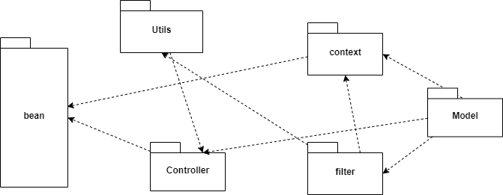

***Package descriptions & package class naming conventions***

|  |  |  |
| --- | --- | --- |
| **No** | **Package** | **Description** |
| 01 | DAO | Used to contain files that arre related to Database Connected Files |
| 02 | controller | Used to contain files that are directly control the system |
| 03 | Utilities | Used to contain files that helps the controllers to manage the system |
| 04 | Filter | Used to contain files whose purpose are user authorization and encoding the web |
| 05 | Model | Used to contain files that represent all the object appear in the project |
|  |  |  |

# II. Code Designs

## 1. Homepage

### a. Class Diagram

### b. Class Specifications

**- BookDAO class**

|  |  |  |
| --- | --- | --- |
| No | Method | Description |
| 01 | getNumberBook | Return an integer which is quantity of books |
| 02 | getWeeklySaleBooks | Return a list contains 4 that has sale in week to display in homepage |
| 03 | getFeaturedBooks | Random selected 15 books in all book to display in homepage |
| 04 | getFavouriteBooks | Get top 3 books that has highest user choose to display in homepage |

**- Book class**

|  |  |  |
| --- | --- | --- |
| No | Method | Description |
| 01 | Book(int id, String title, String author, int categoryid, float rating, int favourite, float price, boolean issale, String image, String description, int views) | Get all information of a books for details |
| 02 | Book(int id, String title, String author, float price, boolean issale, int favourite, String image) | Get general information of a books for display on homepage |

**- Home class**

|  |  |  |
| --- | --- | --- |
| No | Method | Description |
| 01 | processRequest(HttpServletRequest request, HttpServletResponse response) | - ArrayList to take a list from getFeaturedBooks() from Book  - ArrayList to take a list from getWeeklySaleBooks() from Book  - ArrayList to take a list from getFavouriteBooks() from Book |
| 02 | doGet() | Doing processRequest |
| 03 | doPost() | Doing processRequest |

**- DBContext class**

|  |  |  |
| --- | --- | --- |
| No | Method | Description |
| 01 | getConnection() | Connecting with database |

### c. Sequence Diagram(s)

### d. Database queries

- getFeaturedBooks(): “select * from [Book]”

- getWeeklySaleBooks(): "select * from [Book] where [is_sale] = 1"

- getFavoriteBooks(): “select top(3)* from BOOK order by favourite desc”

## 2. Signup

### a. Class Diagram

### b. Class Specifications

**- UserDAO class  
*Class Method***

|  |  |  |
| --- | --- | --- |
| No | Method | Description |
| 01 | getUser | Get username and password |
| 02 | generatePass | Encode users’ password |
| 03 | checkDupEmail | Checking that user’s email is exist or not |
| 04 | checkDupUsername | Checking that user’s username is exist or not |
| 05 | editProfile | Allow user to edit their information |
| 06 | changePassword | Allow user to change their password |
| 07 | getNumberUser | Get Total Number |
| 08 | getAllUser | Taking a list contains all user includes their information |
| 09 | getUserName | Taking user’s ursername |
| 10 | updateUser | Update information of user |
| 11 | checkOldPass | Checking user’s old password when they want to change their one. |

**- User class  
*Class Method***

|  |  |  |
| --- | --- | --- |
| No | Method | Description |
| 01 | User(int id, String name, String gender, String dob, String email, String phone, String address, String username, String password, boolean is_super) | Get all information of user for detail |
| 02 | User(String name, String gender, String dob, String email, String phone, String address, String username, String password) | Get general information of user |

**- DBContext class  
Class Method**

|  |  |  |
| --- | --- | --- |
| No | Method | Description |
| 01 | getConnection() | Connecting with database |

### c. Sequence Diagram(s)

### d. Database queries

- getUser(): "Select * from [User] where (username=? OR email=?) AND password=?"

- checkDupEmail(String email): "select * from [User] where email='" + email + "'"

- checkDupUsername(String key): "select * from [User] where username='" + key + "'"

- createNewUser(String name, String gender, String dob, String email, String phone, String username, String password): "insert [User] ([fullname],[gender] ,[dob] , [email], [phone],[username], [password])"

+ " values (N'" + name + "',"

+ "N'" + (gender.equals("Male") ? 1 : 0) + "',"

+ "CAST(N'" + dob+ "' AS Date),"

+ "N'" + email + "',"

+ "N'" + phone + "',"

+ "N'" + username + "',"

+ "N'" + password + "')"

- editProfile(int userid, String name, String gender, String dob, String email, String phone, String address): "update [User] set "

+ " [fullname] = N'" + name+ "' AND"

+ " [gender] = " + (gender.equals("male") ? 1 : 0) + " AND"

+ " [dob] = N'" + dob + "' AND"

+ " [phone] = N'" + phone + "' AND"

+ " [address] = N'"+ address+"'"

+ "where [id] = "+userid

- changePassword(int userid, String newPassword): "update [User] set " + " [password] = N'" +newPassword + "'"+ "where [id] = "+userid

- getNumberUser(): "select count([id]) from [User] where [is_super] = 'False'"

- getAllUsers(): "Select * from [User] where [is_super] = 0"

- getUsername(int userid): "select [username] from [User] where [id] = "+userid

- updateUser(int id, String name, String phone, String address): "update [User] set "

+ " [fullname] = N'" +name + "'"

+ ", [phone] = N'"+phone+"'"

+ ", [address] = N'"+address+"'"

+ "where [id] = "+id

- checkOldPass(int id,String oldpass): "select * from [User] where [id] = "+id+" AND [password]=N'"+oldpass+"'"

## 3. Login

### a. Class Diagram

### b. Class Specifications

#### LoginController

***Class Methods***

|  |  |  |
| --- | --- | --- |
| **No** | **Method** | **Description** |
| *1* | *doGet()* | *Handles the HTTP <code>GET</code> method.* |
| *2* | *doPost()* | *Handles the HTTP <code>POST</code> method.* |

#### UserDAO

***Class Methods***

|  |  |  |
| --- | --- | --- |
| **No** | **Method** | **Description** |
| *1* | *getUser()* | *Method used to check if an account record existed in database and get all data of that account.Inputs are username and password.Return an <Code>model.User</Code> represents the user’s data* |

#### DBContext

***Class Methods***

|  |  |  |
| --- | --- | --- |
| **No** | **Method** | **Description** |
| *1* | *getConnection* | *Method used to connect to the database. Return a <Code>java.sql.Connection</Code> represents a connection to the database.* |

### c. Sequence Diagram(s)

### d. Database queries

Select * from [User] where (username=? OR email=?) AND password=?

## 4. Logout

### a. Class Diagram

|  |
| --- |
| LogoutController |
| **processRequest(request: HttpServletRequest, response: HttpServletResponse)**  **doGet()**  **doPost()** |

### b. Class Specifications

**- Logout Controller**

|  |  |  |
| --- | --- | --- |
| No | Method | Description |
| 01 | processRequest(HttpServletRequest request, HttpServletResponse response) | - Destroy session  - Redirect to Homepage |
| 02 | doGet() | Doing processRequest |
| 03 | doPost() | Doing processRequest |

### c. Sequence Diagram(s)

### d. Database queries

## 5. Forget password

### a. Class Diagram

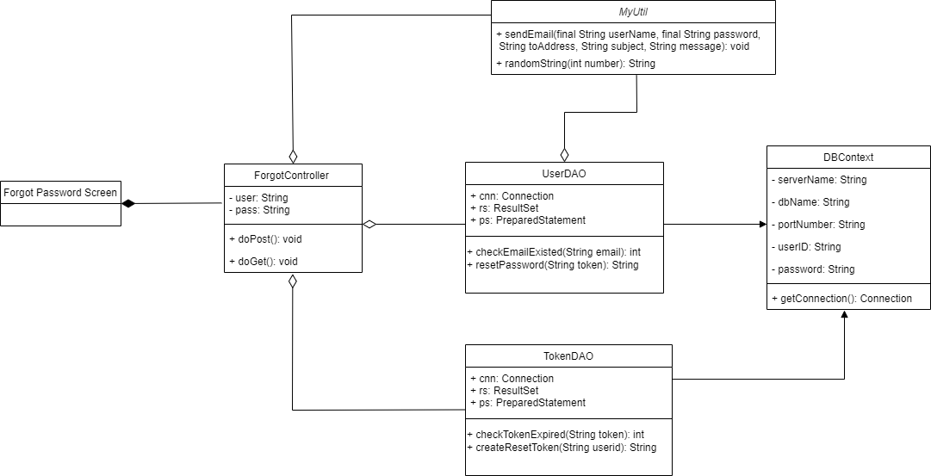

### b. Class Specifications

#### ForgetController

***Class Methods***

|  |  |  |
| --- | --- | --- |
| **No** | **Method** | **Description** |
| *1* | *doGet()* | *Handles the HTTP <code>GET</code> method.* |
| *2* | *doPost()* | *Handles the HTTP <code>POST</code> method.* |

#### UserDAO

#### Class Methods

|  |  |  |
| --- | --- | --- |
| **No** | **Method** | **Description** |
| *1* | *checkEmailExisted* | *Method used to check if an email of a User record existed in the database and get id data of that account. Input is email. Return an Integer represents the account‘s id.* |
| *2* | *resetPassword* | *Method used to update password of a User record if the token input is still in expiration time. Return a String represents the new user’s password* |

#### TokenDAO

#### Class Methods

|  |  |  |
| --- | --- | --- |
| **No** | **Method** | **Description** |
| *1* | *createResetToken* | *Method used to insert a token with expiration time to a Token record . Input is the user's id. Return the generated token as a String* |
| *2* | *checkTokenExpired* | *Method used to check a token valid if the token input is still in expiration time. Return an integer represents userId of that token* |

#### DBContext

***Class Methods***

|  |  |  |
| --- | --- | --- |
| **No** | **Method** | **Description** |
| *1* | *getConnection* | *Method used to connect to the database. Return a connection to the database* |

#### MyUtil

***Class Methods***

|  |  |  |
| --- | --- | --- |
| **No** | **Method** | **Description** |
| *1* | *sendEmail* | *Method used to send an email of a reset instruction. Inputs include recipient’s email and message .* |
| *2* | *randomString* | *Method used to generate a randomized any-number-character string. Return that string.* |

### c. Sequence Diagram(s)

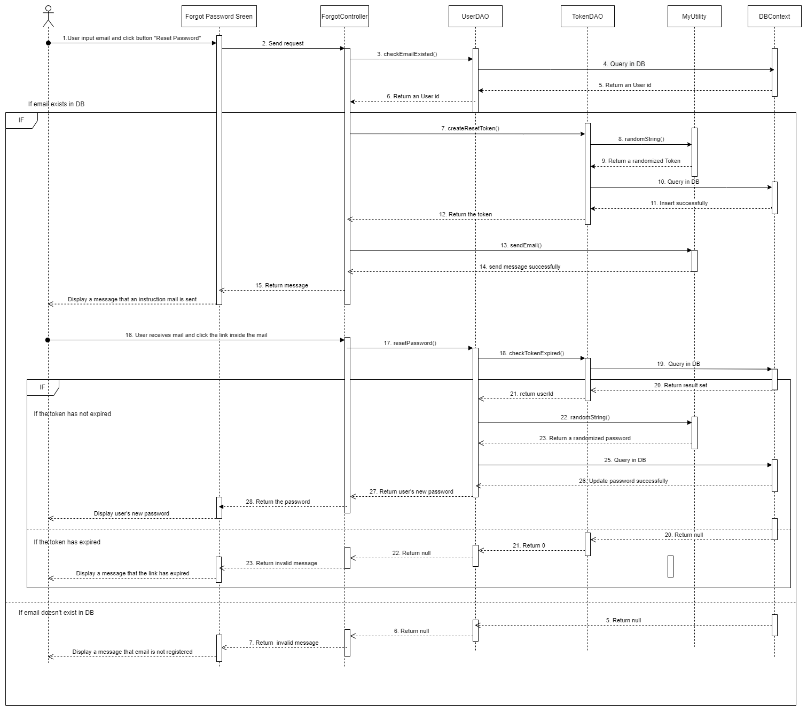

### d. Data queries

* **Get id of a record with specific email from User table**

SELECT id

FROM [User]

WHERE [email] = ?

* **Insert a record with specific user id into Token table**

INSERT INTO [Token]

([userId]

, [token

], [expiredDate])

VALUES ( ?

, ?

, ?)

* **Update password of a record in User table**

UPDATE [User]

SET [password] = ?

WHERE [id] =  ?

## 6. View Admin Profile

### a. Class Diagram

### b. Class Specifications

#### LoginController

***Class Methods***

|  |  |  |
| --- | --- | --- |
| **No** | **Method** | **Description** |
| *1* | *doPost()* | *Handles the HTTP <code>POST</code> method.* |

#### EditController

***Class Methods***

|  |  |  |
| --- | --- | --- |
| **No** | **Method** | **Description** |
| *1* | *doGet()* | *Handles the HTTP <code>GET</code> method.* |

#### UserDAO

***Class Methods***

|  |  |  |
| --- | --- | --- |
| **No** | **Method** | **Description** |
| *1* | *getUser()* | *Method used to check if an account record existed in database and get all data of that account.Inputs are username and password.Return an <Code>model.User</Code> represents the user’s data* |

#### DBContext

***Class Methods***

|  |  |  |
| --- | --- | --- |
| **No** | **Method** | **Description** |
| *1* | *getConnection* | *Method used to connect to the database. Return a <Code>java.sql.Connection</Code> represents a connection to the database.* |

### c. Sequence Diagram(s)

### d. Database queries

Select * from [User] where (username=? OR email=?) AND password=?

## 7. Update Admin Profile

### a. Class Diagram

### b. Class Specifications

#### EditController

***Class Methods***

|  |  |  |
| --- | --- | --- |
| **No** | **Method** | **Description** |
| *1* | *doGet()* | *Handles the HTTP <code>GET</code> method.* |
| *2* | *doPost()* | *Handles the HTTP <code>POST</code> method.* |

#### UserDAO

***Class Methods***

|  |  |  |
| --- | --- | --- |
| **No** | **Method** | **Description** |
| *1* | *editProfile()* | *Method used to let admin update the data of that account.Inputs are admin details.Update those to database.* |

#### DBContext

***Class Methods***

|  |  |  |
| --- | --- | --- |
| **No** | **Method** | **Description** |
| *1* | *getConnection* | *Method used to connect to the database. Return a <Code>java.sql.Connection</Code> represents a connection to the database.* |

### c. Sequence Diagram(s)

### d. Database queries

update[User] set

[email] = ?,

[fullname] = ?,

[phone] = ?,

[address] = ?

where [id] = ?

## 8. View list book

### a. Class Diagram

### b. Class Specifications

#### BookController

***Class Methods***

|  |  |  |
| --- | --- | --- |
| **No** | **Method** | **Description** |
| *1* | *doGet()* | *Get categoryID from the HomePage( when user interact with the system ) then start get data from BookDAO to collect books that match the categoryID comefrom Homepage* |

#### BookDAO

***Class Methods***

|  |  |  |
| --- | --- | --- |
| **No** | **Method** | **Description** |
| *1* | *getBooks()* | *Get all the book in the list book* |
| *2* | *getBookBycID(cID)* | *Get all the books that match the cID* |

#### CategoryDAO

***Class Methods***

|  |  |  |
| --- | --- | --- |
| **No** | **Method** | **Description** |
| *1* | *getCategory()* | *Get the specify category from List Category* |

#### DBContext

***Class Methods***

|  |  |  |
| --- | --- | --- |
| **No** | **Method** | **Description** |
| *1* | *getConnection* | *Method used to connect to the database. Return a <Code>java.sql.Connection</Code> represents a connection to the database.* |

### c. Sequence Diagram(s)

### d. Data queries

* select * from [Category]
* select * from [Book] where [categoryid] =
* select * from [Book]

## 9. View book details

### a. Class Diagram

### b. Class Specifications

#### BookController

***Class Methods***

|  |  |  |
| --- | --- | --- |
| **No** | **Method** | **Description** |
| *1* | *doGet()* | *Get bookID from the Homepage(when user interact with the system )then start get the data from BookDAO to collect books that match the bookID come from home page* |

#### BookDAO

***Class Methods***

|  |  |  |
| --- | --- | --- |
| **No** | **Method** | **Description** |
| *1* | *getBooksByID(ID)* | *Get book match the ID* |

#### CategoryDAO

***Class Methods***

|  |  |  |  |
| --- | --- | --- | --- |
| **No** |  | **Method** | **Description** |
| *1* |  | *getCategory()* | *Get the specify category from List Category* |

#### DBContext

***Class Methods***

|  |  |  |
| --- | --- | --- |
| **No** | **Method** | **Description** |
| *1* | *getConnection* | *Method used to connect to the database. Return a <Code>java.sql.Connection</Code> represents a connection to the database.* |

### c. Sequence Diagram(s)

### d. Data queries

* select * from [Book] where [id] =

## 10. Profile

### a. Class Diagram

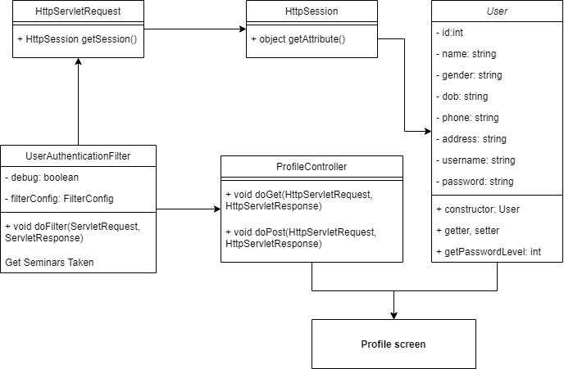

### b. Class Specifications

#### ProfileController class

|  |  |  |
| --- | --- | --- |
| **No** | **Method** | **Description** |
| 01 | doGet | Handles the HTTP <code>GET</code> method. |
| 02 | doPost | Handles the HTTP <code>POST</code> method. |

#### UserAuthenticationFilter class

|  |  |  |
| --- | --- | --- |
| **No** | **Method** | **Description** |
| 01 | doFilter | Handles the HTTP <code>GET</code> method. |

### c. Sequence Diagram(s)

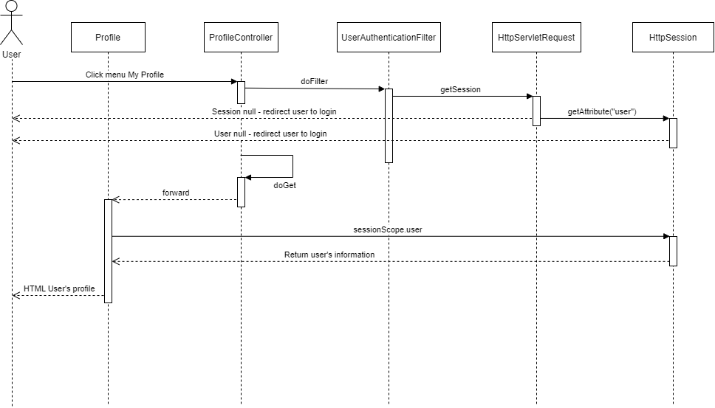

### d. Database queries

## 11. Edit profile

### a. Class Diagram

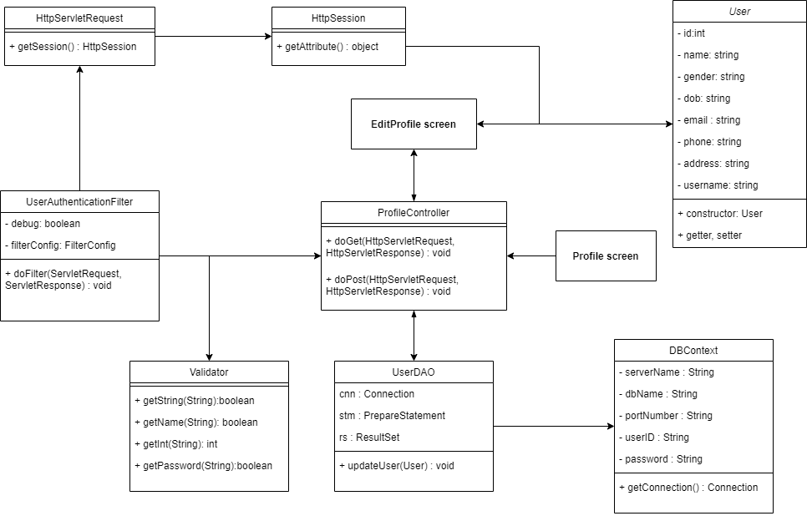

### b. Class Specifications

#### ProfileController class

|  |  |  |
| --- | --- | --- |
| **No** | **Method** | **Description** |
| 01 | doGet | Handles the HTTP <code>GET</code> method. |
| 02 | doPost | Handles the HTTP <code>POST</code> method. |

#### UserAuthenticationFilter class

|  |  |  |
| --- | --- | --- |
| **No** | **Method** | **Description** |
| 01 | doFilter | Handles the HTTP <code>GET</code> method. |

#### User class

|  |  |  |
| --- | --- | --- |
| **No** | **Method** | **Description** |
| 01 | getId | Get ID of user |
| 02 | getName | Get name of user |
| 03 | getGender | Get gender of user |
| 04 | getPhone | Get phone number of user |
| 05 | getAddress | Get address of user |
| 06 | getEmail | Get email of user |
| 07 | setName | Set name of user |
| 08 | setPhone | Set phone number of user |
| 09 | setAddress | Set address of user |
| 10 | setGender | Set gender of user |

#### UserDAO class

|  |  |  |
| --- | --- | --- |
| **No** | **Method** | **Description** |
| 01 | updateProfile | Update information of user in database |

#### Validator class

|  |  |  |
| --- | --- | --- |
| **No** | **Method** | **Description** |
| 01 | getString | Check if string is empty |
| 02 | getName | Check if name is empty or contains digit or so long |

### c. Sequence Diagram(s)

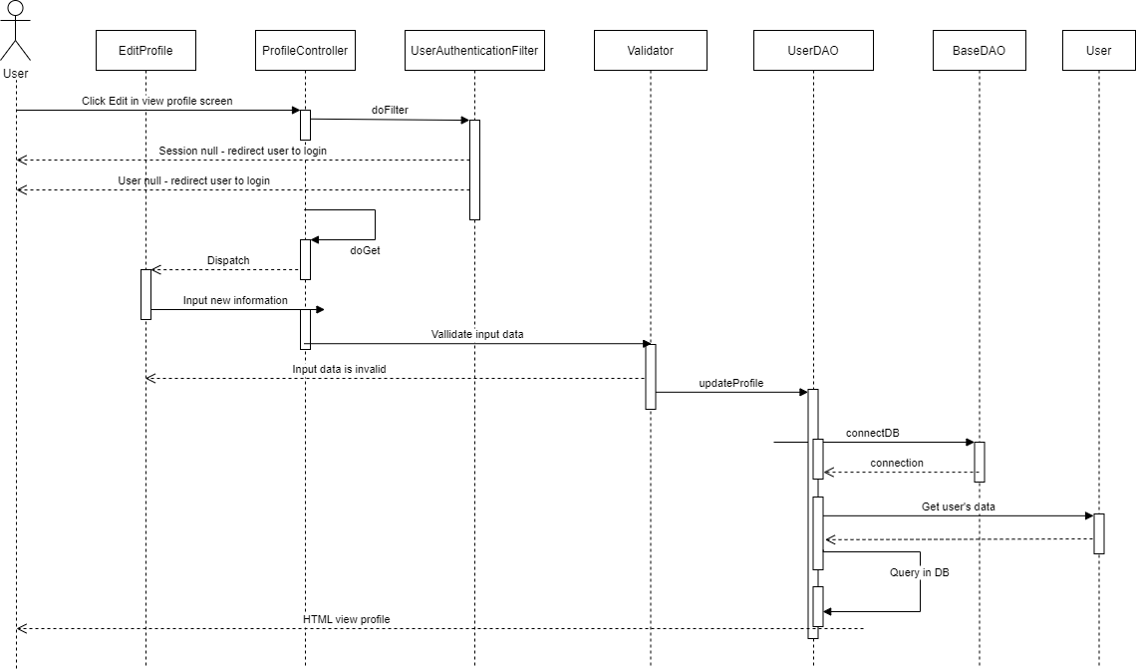

### d. Database queries

update [User] set [fullname] = ?, [phone] = ?, [address] = ?, [gender] = ?, [dob] = ? where [id] = ?

## 12. View security

### a. Class Diagram

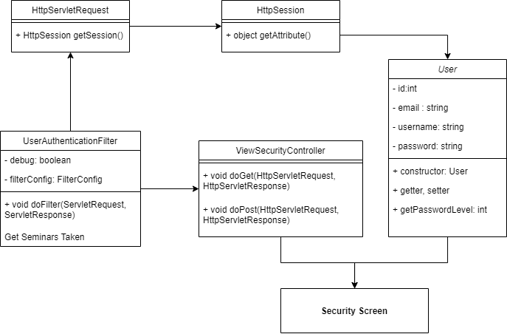

### b. Class Specifications

#### ProfileController class

|  |  |  |
| --- | --- | --- |
| **No** | **Method** | **Description** |
| 01 | doGet | Handles the HTTP <code>GET</code> method. |
| 02 | doPost | Handles the HTTP <code>POST</code> method. |

#### UserAuthenticationFilter class

|  |  |  |
| --- | --- | --- |
| **No** | **Method** | **Description** |
| 01 | doFilter | Handles the HTTP <code>GET</code> method. |

#### User class

|  |  |  |
| --- | --- | --- |
| **No** | **Method** | **Description** |
| 01 | getEmail | Get email of user |
| 02 | getPasswordLevel | Get level of password |

### c. Sequence Diagram(s)

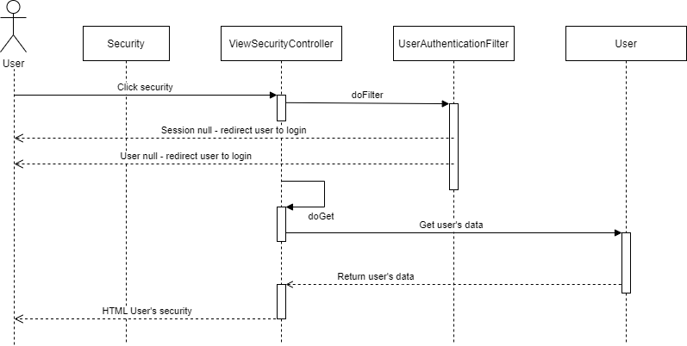

### d. Database queries

## 13. Change password

### a. Class Diagram

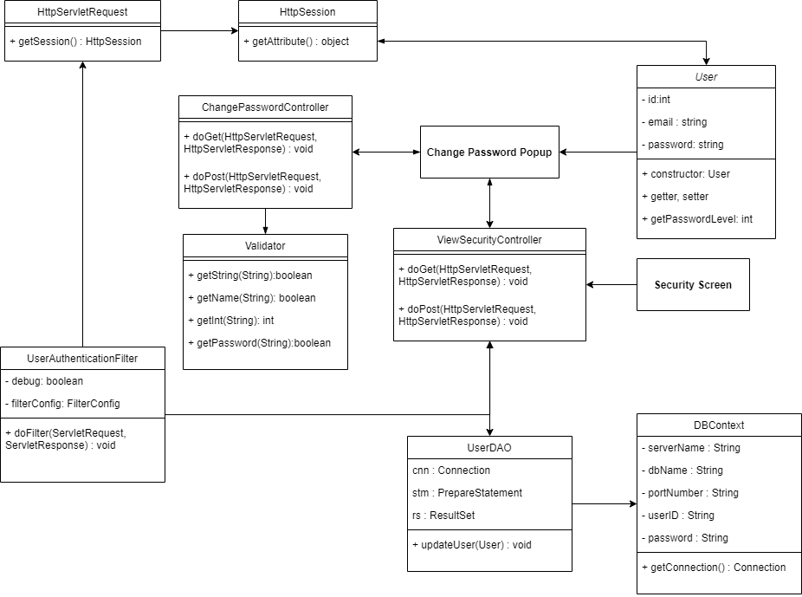

### b. Class Specifications

#### ProfileController class

|  |  |  |
| --- | --- | --- |
| **No** | **Method** | **Description** |
| 01 | doGet | Handles the HTTP <code>GET</code> method. |
| 02 | doPost | Handles the HTTP <code>POST</code> method. |

#### UserAuthenticationFilter class

|  |  |  |
| --- | --- | --- |
| **No** | **Method** | **Description** |
| 01 | doFilter | Handles the HTTP <code>GET</code> method. |

#### User class

|  |  |  |
| --- | --- | --- |
| **No** | **Method** | **Description** |
| 01 | getPassword | Get password of user |
| 02 | getId | Get ID of user |

#### UserDAO class

|  |  |  |
| --- | --- | --- |
| **No** | **Method** | **Description** |
| 01 | changePassword | Change password of user by id and new password |

#### Validator class

|  |  |  |
| --- | --- | --- |
| **No** | **Method** | **Description** |
| 01 | getString | Check if string is empty |
| 02 | getPassword | Check if password is valid |

### c. Sequence Diagram(s)

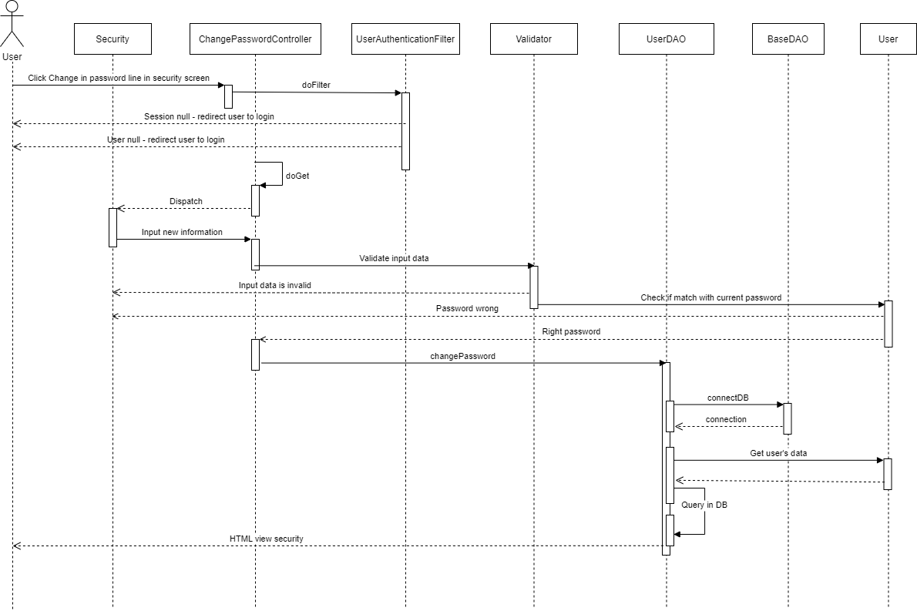

### d. Database queries

update [User] set [password] = ? where [id] = ?

## 14. Comment

### a. Class diagram

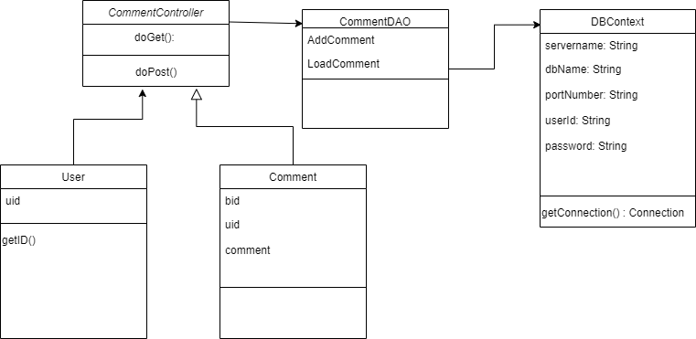

### b. Class Specifications

#### CommentController class

|  |  |  |
| --- | --- | --- |
| **No** | **Method** | **Description** |
| 01 | doGet | Handles the HTTP <code>GET</code> method. |
| 02 | doPost | Handles the HTTP <code>POST</code> method. |

#### CommentDAO class

|  |  |  |
| --- | --- | --- |
| **No** | **Method** | **Description** |
| 01 | loadComment | Get all the comment of 1 book |
| 02 | addComment | Insert comment into database |

#### User class

|  |  |  |
| --- | --- | --- |
| **No** | **Method** | **Description** |
| 01 | getID | Get the ID of the user |

#### DBContext class

|  |  |  |
| --- | --- | --- |
| **No** | **Method** | **Description** |
| 01 | connectDB | Get connection from database |

### c. Sequence Diagram

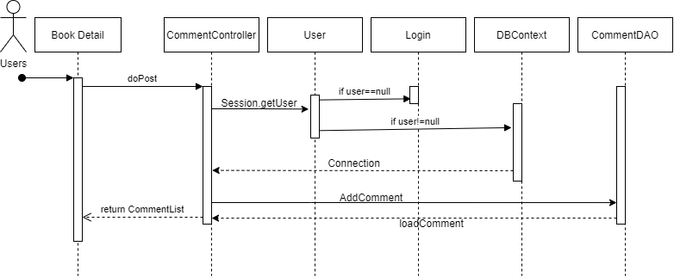

### d. Database queries

* INSERT [Comment] VALUES ([bid]='"+bid+"',[uid]='"+uid+"',[comment]='"+comment+"')
* SELECT * FROM [Comment] WHERE [bid]='"+bid+"'

## 15. Rating Book

### a. Class diagram

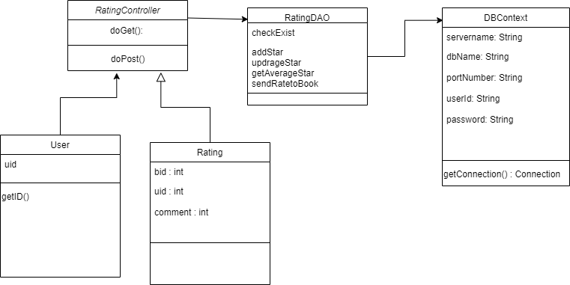

### b. Class Specifications

#### RatingController class

|  |  |  |
| --- | --- | --- |
| **No** | **Method** | **Description** |
| 01 | doGet | Handles the HTTP <code>GET</code> method. |
| 02 | doPost | Handles the HTTP <code>POST</code> method. |

#### RatingDAO class

|  |  |  |
| --- | --- | --- |
| **No** | **Method** | **Description** |
| 01 | checkExist | Check the existance of the rating in the database |
| 02 | addStar | Insert rating into database |
| 03 | updateStar | Update the existed rating in the database |
| 04 | getAverageStar | Take the Rating of the book |
| 05 | sendRatetoBook | Send the average star from [Star] to [Book] |

#### User class

|  |  |  |
| --- | --- | --- |
| **No** | **Method** | **Description** |
| 01 | getID | Get the ID of the user |

#### DBContext class

|  |  |  |
| --- | --- | --- |
| **No** | **Method** | **Description** |
| 01 | connectDB | Get connection from database |

### c. Sequence Diagram

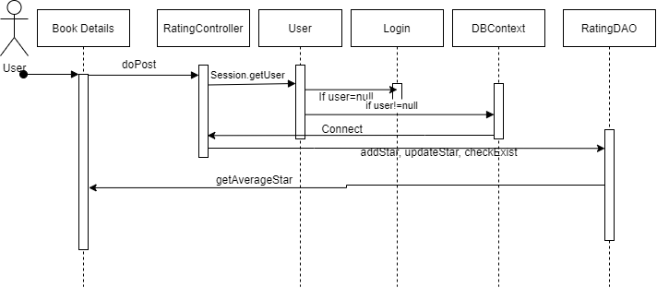

### d. Database queries

- UPDATE [Book] SET [rate]='"+star+"' WHERE [bid]='"+bid+"'

- INSERT INTO [Star] VALUES ([bid]='"+bid+"',[uid]='"+uid+"',[star]='"+star+"')

- UPDATE [Star] SET [star]='"+star+"' WHERE [bid]='"+bid+"' and [uid]='"+uid+"'

- SELECT * FROM [Star] WHERE [bid]='"+bid+"',uid='"+uid+"'

- SELECT * FROM [Star] WHERE [bid]='"+bid+"'

## 16. Add to Favorite

### a. Class diagram

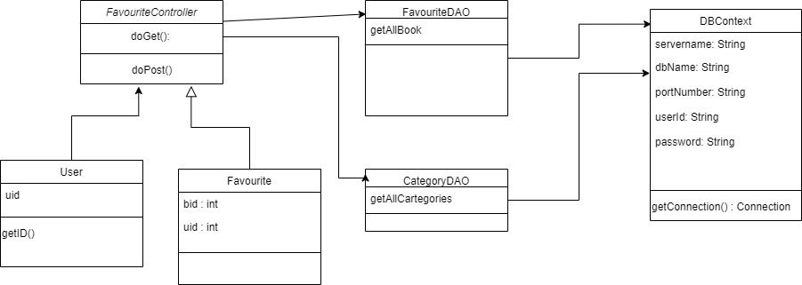

### b. Class Specifications

#### FavouriteController class

|  |  |  |
| --- | --- | --- |
| **No** | **Method** | **Description** |
| 01 | doGet | Handles the HTTP <code>GET</code> method. |
| 02 | doPost | Handles the HTTP <code>POST</code> method. |

#### FavouriteDAO class

|  |  |  |
| --- | --- | --- |
| **No** | **Method** | **Description** |
| 01 | getAllbook | Get all the favourite book of 1 user |

#### BookDAO class

|  |  |  |
| --- | --- | --- |
| **No** | **Method** | **Description** |
| 01 | getBookById | Get the specific book by its id |

#### CategoryDAO class

|  |  |  |
| --- | --- | --- |
| **No** | **Method** | **Description** |
| 01 | getAllCategories | Get all the categories of the books |

#### User class

|  |  |  |
| --- | --- | --- |
| **No** | **Method** | **Description** |
| 01 | getID | Get the ID of the user |

#### DBContext class

|  |  |  |
| --- | --- | --- |
| **No** | **Method** | **Description** |
| 01 | connectDB | Get connection from database |

### c. Sequence Diagram

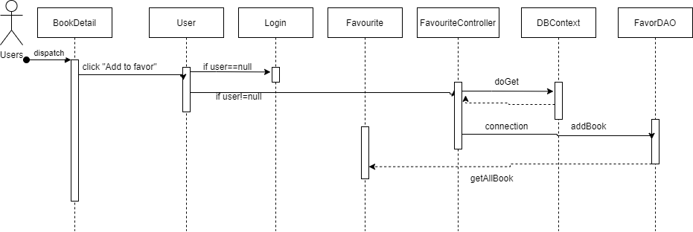

### d. Database queries

- INSERT INTO [Favourite]\n"+"([uid]\n"+",[bid])\n"+ "VALUES\n"+ "("+ uID +",\n" +""+ bID + ")

- SELECT * FROM [Favourite] WHERE uid='" + uID + "'

## 17. Report Book

### a. Class diagram

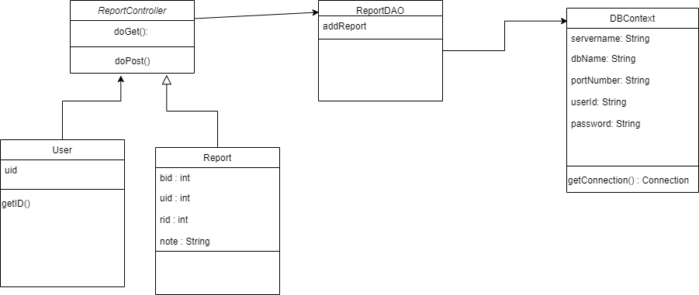

### b. Class Specifications

#### ReportController class

|  |  |  |
| --- | --- | --- |
| **No** | **Method** | **Description** |
| 01 | doGet | Handles the HTTP <code>GET</code> method. |
| 02 | doPost | Handles the HTTP <code>POST</code> method. |

#### ReportDAO class

|  |  |  |
| --- | --- | --- |
| **No** | **Method** | **Description** |
| 01 | addReport | Insert report into database |

#### User class

|  |  |  |
| --- | --- | --- |
| **No** | **Method** | **Description** |
| 01 | getID | Get the ID of the user |

#### DBContext class

|  |  |  |
| --- | --- | --- |
| **No** | **Method** | **Description** |
| 01 | connectDB | Get connection from database |

### c. Sequence Diagram

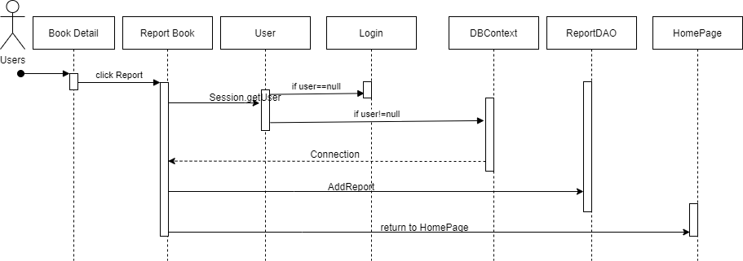

### d. Database queries

**-** INSERT INTO [ReportDetail] (reportId,bookId,userId,note) "+ "VALUES ('"+rid+"','"+bid+"','"+uid+"','"+note+"')

## 18.1 View List Books

### a. Class Diagram

### b. Class Specifications

#### BooksController

***Class Methods***

|  |  |  |
| --- | --- | --- |
| **No** | **Method** | **Description** |
| *1* | *doGet()* | *Handles the HTTP <code>GET</code> method.* |
| *2* | *doPost()* | *Handles the HTTP <code>POST</code> method.* |

#### BookDAO

***Class Methods***

|  |  |  |
| --- | --- | --- |
| **No** | **Method** | **Description** |
| *1* | *getAllBook* | *Method used to get all book and its information in database. Return an array list <Book> represents the data of books.* |
| *2* | *getByPage* | *Method used to divide list of books to many page. Return an array list <Book> represents the data of books.* |

#### CategoryDAO

***Class Methods***

|  |  |  |
| --- | --- | --- |
| **No** | **Method** | **Description** |
| *1* | *getAllCategory* | *Method used to get all category and its information in database. Return an array list <Category> represents the data of books.* |

#### DBContext

***Class Methods***

|  |  |  |
| --- | --- | --- |
| **No** | **Method** | **Description** |
| *1* | *getConnection* | *Method used to connect to the database. Return a <Code>java.sql.Connection</Code> represents a connection to the database.* |

#### 

### c. Sequence Diagram(s)

### d. Data queries

1. getAllBook

SELECT [id]\n"

+ " ,[title]\n"

+ " ,[author]\n"

+ " ,[categoryid]\n"

+ " ,[rating]\n"

+ " ,[favourite]\n"

+ " ,[price]\n"

+ " ,[is_sale]\n"

+ " ,[image]\n"

+ " ,[description]\n"

+ " ,[views]\n"

+ " ,[status]\n"

+ " FROM [dbo].[Book]"

2. getAllCategory

SELECT [id]

,[name]

FROM [dbo].[Category]

## 18.2 Add Book

### a. Class Diagram

### b. Class Specifications

#### AddBookController

***Class Methods***

|  |  |  |
| --- | --- | --- |
| **No** | **Method** | **Description** |
| *1* | *doGet()* | *Handles the HTTP <code>GET</code> method.* |
| *2* | *doPost()* | *Handles the HTTP <code>POST</code> method.* |

#### BookDAO

***Class Methods***

|  |  |  |
| --- | --- | --- |
| **No** | **Method** | **Description** |
| *1* | *countBookNumber* | *Method used to count the number of books in database. Return the number of books available.* |
| *2* | *addBook* | *Method used to insert the data of a new book into Book table. Return an integer represents result of query execution.* |

#### 

#### CategoryDAO

***Class Methods***

|  |  |  |
| --- | --- | --- |
| **No** | **Method** | **Description** |
| *1* | *getAllCategory* | *Method used to get all category and its information in database. Return an array list <Category> represents the data of books.* |

#### DBContext

***Class Methods***

|  |  |  |
| --- | --- | --- |
| **No** | **Method** | **Description** |
| *1* | *getConnection* | *Method used to connect to the database. Return a <Code>java.sql.Connection</Code> represents a connection to the database.* |

#### 

### c. Sequence Diagram(s)

### d. Data queries

1. addBook:

INSERT INTO [dbo].[Book]\n"

+ " ([title]\n"

+ " ,[author]\n"

+ " ,[categoryid]\n"

+ " ,[price]\n"

+ " ,[is_sale]\n"

+ " ,[image]\n"

+ " ,[description])\n"

+ " VALUES ( ? "

+ " , ? "

+ " , ? "

+ " , ? "

+ " , ? "

+ " , ? "

+ " , ? )”

2. countNumberBook

SELECT COUNT([id]) FROM [dbo].[Book]

## 18.3 Update Book

### a. Class Diagram

### b. Class Specifications

#### UpdateBookController

***Class Methods***

|  |  |  |
| --- | --- | --- |
| **No** | **Method** | **Description** |
| *1* | *doGet()* | *Handles the HTTP <code>GET</code> method.* |
| *2* | *doPost()* | *Handles the HTTP <code>POST</code> method.* |

**BookDAO**

***Class Methods***

|  |  |  |
| --- | --- | --- |
| **No** | **Method** | **Description** |
| *1* | *getBookById* | *Method used to get the data of book that has the input id and return the book* |
| *2* | *editBook* | *Method used to update Book into database and return an integer represents sql query result* |

**CategoryDAO**

***Class Methods***

|  |  |  |
| --- | --- | --- |
| **No** | **Method** | **Description** |
| *1* | *getAllCategory* | *Method used to get all category and its information in database. Return an array list <Category> represents the data of books.* |

#### DBContext

***Class Methods***

|  |  |  |
| --- | --- | --- |
| **No** | **Method** | **Description** |
| *1* | *getConnection* | *Method used to connect to the database. Return a <Code>java.sql.Connection</Code> represents a connection to the database.* |

#### 

### c. Sequence Diagram(s)

### 

### d. Data queries

1.*editBook*

UPDATE [Book] "

+ "SET [title]= ?"

+ ", [author] = ? "

+ ", [categoryid] = ?"

+ ", [price] = ?"

+ ", [is_sale] = ?"

+ ", [image] = ?"

+ ", [description] = ?"

+ " WHERE [id] = ? "

2. getBookById

SELECT [id]\n"

+ " ,[title]\n"

+ " ,[author]\n"

+ " ,[categoryid]\n"

+ " ,[rating]\n"

+ " ,[favourite]\n"

+ " ,[price]\n"

+ " ,[is_sale]\n"

+ " ,[image]\n"

+ " ,[description]\n"

+ " ,[views]\n"

+ " ,[status]\n"

+ " FROM [dbo].[Book]"

+ "WHERE [id] = ?"

## 18.4. Disable/Enable Book

### a. Class Diagram

### b. Class Specifications

**ChangeStatusController**

***Class Methods***

|  |  |  |
| --- | --- | --- |
| **No** | **Method** | **Description** |
| *1* | *doGet()* | *Handles the HTTP <code>GET</code> method.* |
| *2* | *doPost()* | *Handles the HTTP <code>POST</code> method.* |

**BookDAO**

***Class Methods***

|  |  |  |
| --- | --- | --- |
| **No** | **Method** | **Description** |
| *1* | *changeStatusById* | *Method used to update status column of the book tuple in database that has the input id.* |

**CategoryDAO**

***Class Methods***

|  |  |  |
| --- | --- | --- |
| **No** | **Method** | **Description** |
| *1* | *getAllCategory* | *Method used to get all category and its information in database. Return an array list <Category> represents the data of books.* |

#### DBContext

***Class Methods***

|  |  |  |
| --- | --- | --- |
| **No** | **Method** | **Description** |
| *1* | *getConnection* | *Method used to connect to the database. Return a <Code>java.sql.Connection</Code> represents a connection to the database.* |

### c. Sequence Diagram(s)

### d. Data queries

- changeStatus

UPDATE [Book]"

+ " SET [status] = 1 ^ [status] "

+ " WHERE [id] = ?"

## 19.1 View Table of Contents

### a. Class Diagram

### b. Class Specifications

**TOCController**

***Class Methods***

|  |  |  |
| --- | --- | --- |
| **No** | **Method** | **Description** |
| *1* | *doGet()* | *Handles the HTTP <code>GET</code> method.* |
| *2* | *doPost()* | *Handles the HTTP <code>POST</code> method.* |

**BookDAO**

***Class Methods***

|  |  |  |
| --- | --- | --- |
| **No** | **Method** | **Description** |
| *1* | *getBookById* | *Method used to get the data of book that has the input id and return the book* |

**VolumeDAO**

***Class Methods***

|  |  |  |
| --- | --- | --- |
| **No** | **Method** | **Description** |
| *1* | *getAllVolume* | *Method used to get all volume and their information of a book has the input id in database. Return an array list <Volume> represents the data of volumes.* |
| *2* | *getVolumeById* | *Method used to get the data of volume that has the input id and return the volume* |

**ChapterDAO**

***Class Methods***

|  |  |  |
| --- | --- | --- |
| **No** | **Method** | **Description** |
| *1* | *getAllChapter* | *Method used to get all chapter and its information of a book has the input id in database. Return an array list <Chapter> represents the data of chapters.* |
| *2* | *getChapterById* | *Method used to get the data of chapter that has the input id and return the chapter* |

**DBContext**

***Class Methods***

|  |  |  |
| --- | --- | --- |
| **No** | **Method** | **Description** |
| *1* | *getConnection* | *Method used to connect to the database. Return a <Code>java.sql.Connection</Code> represents a connection to the database.* |

### c. Sequence Diagram(s)

### d. Data queries

1. getAllVolume

SELECT [id]\n"

+ " ,[volume]\n"

+ " ,[volumeName]\n"

+ " ,[summary]\n"

+ " FROM [dbo].[Volume]"

+ " WHERE [bookId] = ? "

+ " ORDER BY [volume] asc"

2. getAllChapter

SELECT [id]\n"

+ " ,[volumeId]\n"

+ " ,[chapter]\n"

+ " ,[chapterName]\n"

+ " ,[status]\n"

+ " FROM [dbo].[Chapter]"

+ " WHERE [bookId] = ?"

+ " ORDER BY [chapter] asc"

3. getVolumeById

SELECT [id]\n"

+ " ,[bookId]\n"

+ " ,[volume]\n"

+ " ,[volumeName]\n"

+ " ,[summary]\n"

+ " FROM [dbo].[Volume]"

+ " WHERE [id] = ? "

4. getChapterById

SELECT [id]\n"

+ " ,[bookId]\n"

+ " ,[volumeId]\n"

+ " ,[chapter]\n"

+ " ,[chapterName]\n"

+ " ,[status]\n"

+ " ,[content]\n"

+ " FROM [dbo].[Chapter]"

+ " WHERE [id] = ?"

## 19.2 Add Volume

### a. Class Diagram

### b. Class Specifications

#### AddVolumeController

***Class Methods***

|  |  |  |
| --- | --- | --- |
| **No** | **Method** | **Description** |
| *1* | *doGet()* | *Handles the HTTP <code>GET</code> method.* |
| *2* | *doPost()* | *Handles the HTTP <code>POST</code> method.* |

#### BookDAO

***Class Methods***

|  |  |  |
| --- | --- | --- |
| **No** | **Method** | **Description** |
| *1* | *getBookById* | *Method used to get the data of book that has the input id and return the book* |

#### VolumeDAO

***Class Methods***

|  |  |  |
| --- | --- | --- |
| **No** | **Method** | **Description** |
| *1* | *getAllVolume* | *Method used to get all volume and their information of a book has the input id in database. Return an array list <Volume> represents the data of volumes.* |
| *2* | *addVolume* | *Method used to insert the data of new volume into database. Input is volume model. Return an integer represents sql query result.* |
| *3* | *getNewVolume* | *Methos used to get the newest volume in database. Return a Volume represents the data of volume.* |

#### ChapterDAO

***Class Methods***

|  |  |  |
| --- | --- | --- |
| **No** | **Method** | **Description** |
| *1* | *getAllChapter* | *Method used to get all chapter and its information of a book has the input id in database. Return an array list <Chapter> represents the data of chapters.* |

#### DBContext

***Class Methods***

|  |  |  |
| --- | --- | --- |
| **No** | **Method** | **Description** |
| *1* | *getConnection* | *Method used to connect to the database. Return a <Code>java.sql.Connection</Code> represents a connection to the database.* |

### c. Sequence Diagram(s)

### d. Data queries

#### - addVolume

INSERT INTO [dbo].[Volume]\n"

+ " ([bookId]\n"

+ " ,[volume]\n"

+ " ,[volumeName]\n"

+ " ,[summary])\n"

+ " VALUES ( ?"

+ " , (SELECT COUNT([volume]) FROM [dbo].[Volume] WHERE [bookId] = ?)+1"

+ " , ?"

+ " , ? )"

- getNewVolume

SELECT TOP 1 [id]\n"

+ " ,[bookId]\n"

+ " ,[volume]\n"

+ " ,[volumeName]\n"

+ " ,[summary]\n"

+ " FROM [dbo].[Volume]"

+ " WHERE [bookId] = ? "

+ " ORDER BY [volume] DESC"

## 19.3. Edit Volume

### a. Class Diagram

### b. Class Specifications

#### EditVolumeController

***Class Methods***

|  |  |  |
| --- | --- | --- |
| **No** | **Method** | **Description** |
| *1* | *doGet()* | *Handles the HTTP <code>GET</code> method.* |
| *2* | *doPost()* | *Handles the HTTP <code>POST</code> method.* |

#### BookDAO

***Class Methods***

|  |  |  |
| --- | --- | --- |
| **No** | **Method** | **Description** |
| *1* | *getBookById* | *Method used to get the data of book that has the input id and return the book* |

#### VolumeDAO

***Class Methods***

|  |  |  |
| --- | --- | --- |
| **No** | **Method** | **Description** |
| *1* | *getAllVolume* | *Method used to get all volume and their information of a book has the input id in database. Return an array list <Volume> represents the data of volumes.* |
| *2* | *editVolume* | *Method used to update the data of a Volume in database. Input is volume model. Return an integer represents sql query result.* |
| *3* | *getVolumeById* | *Method used to get the data of volume that has the input id and return the volume* |

#### ChapterDAO

***Class Methods***

|  |  |  |
| --- | --- | --- |
| **No** | **Method** | **Description** |
| *1* | *getAllChapter* | *Method used to get all chapter and its information of a book has the input id in database. Return an array list <Chapter> represents the data of chapters.* |

#### DBContext

***Class Methods***

|  |  |  |
| --- | --- | --- |
| **No** | **Method** | **Description** |
| *1* | *getConnection* | *Method used to connect to the database. Return a <Code>java.sql.Connection</Code> represents a connection to the database.* |

### c. Sequence Diagram(s)

### d. Data queries

- editVolume

UPDATE [dbo].[Volume]\n"

+ " SET [volumeName] = ? "

+ " ,[summary] = ? "

+ " WHERE [id] = ? "

## 19.4. Delete Volume

### a. Class Diagram

### b. Class Specifications

#### DeleteVolumeController

***Class Methods***

|  |  |  |
| --- | --- | --- |
| **No** | **Method** | **Description** |
| *1* | *doGet()* | *Handles the HTTP <code>GET</code> method.* |
| *2* | *doPost()* | *Handles the HTTP <code>POST</code> method.* |

#### VolumeDAO

***Class Methods***

|  |  |  |
| --- | --- | --- |
| **No** | **Method** | **Description** |
| *1* | *deleteVolumeAndItsChapter* | *Method used to delete the data of a volume and all of its chapter in database. Input is volume id.* |

#### DBContext

***Class Methods***

|  |  |  |
| --- | --- | --- |
| **No** | **Method** | **Description** |
| *1* | *getConnection* | *Method used to connect to the database. Return a <Code>java.sql.Connection</Code> represents a connection to the database.* |

### c. Sequence Diagram(s)

### d. Data queries

- deleteVolumeAndItsChapter

DELETE FROM [dbo].[Volume]\n"

+ " WHERE [id] = ? "

## 19.5 Add Chapter

### a. Class Diagram

### b. Class Specifications

**AddChapterController**

***Class Methods***

|  |  |  |
| --- | --- | --- |
| **No** | **Method** | **Description** |
| *1* | *doGet()* | *Handles the HTTP <code>GET</code> method.* |
| *2* | *doPost()* | *Handles the HTTP <code>POST</code> method.* |

**BookDAO**

***Class Methods***

|  |  |  |
| --- | --- | --- |
| **No** | **Method** | **Description** |
| *1* | *getBookById* | *Method used to get the data of book that has the input id and return the book* |

**VolumeDAO**

***Class Methods***

|  |  |  |
| --- | --- | --- |
| **No** | **Method** | **Description** |
| *1* | *getAllVolume* | *Method used to get all volume and their information of a book has the input id in database. Return an array list <Volume> represents the data of volumes.* |
| *2* | *getVolumeById* | *Method used to get the data of volume that has the input id and return the volume* |

**ChapterDAO**

***Class Methods***

|  |  |  |
| --- | --- | --- |
| **No** | **Method** | **Description** |
| *1* | *getAllChapter* | *Method used to get all chapter and its information of a book has the input id in database. Return an array list <Chapter> represents the data of chapters.* |
| *2* | *addChapter* | *Method used to insert the data of new chapter into database. Input is chapter model. Return an integer represents sql query result.* |
| *3* | *getNewChapter* | *Methos used to get the newest chapter in database. Return a Chapter object represents the data of chapter.* |

**DBContext**

***Class Methods***

|  |  |  |
| --- | --- | --- |
| **No** | **Method** | **Description** |
| *1* | *getConnection* | *Method used to connect to the database. Return a <Code>java.sql.Connection</Code> represents a connection to the database.* |

### c. Sequence Diagram(s)

### d. Data queries

- addChapter

INSERT INTO [dbo].[Chapter]\n"

+ " ([bookId]\n"

+ " ,[volumeId]\n"

+ " ,[chapter]\n"

+ " ,[chapterName]\n"

+ " ,[status]\n"

+ " ,[content])\n"

+ " VALUES\n"

+ " ( ? "

+ " , ? "

+ " , (SELECT COUNT([chapter]) FROM [dbo].[Chapter] WHERE [volumeId] = ?)+1 "

+ " , ? "

+ " , ? "

+ " , ? )"

- getNewChapter

SELECT TOP 1 [id]\n"

+ " ,[volumeId]\n"

+ " ,[chapter]\n"

+ " ,[chapterName]\n"

+ " ,[status]\n"

+ " ,[content]\n"

+ " FROM [dbo].[Chapter]"

+ "WHERE [bookId] = ? "

+ "ORDER BY [chapter] DESC "

## 19.6 Edit Chapter

### a. Class Diagram

### b. Class Specifications

**EditChapterController**

***Class Methods***

|  |  |  |
| --- | --- | --- |
| **No** | **Method** | **Description** |
| *1* | *doGet()* | *Handles the HTTP <code>GET</code> method.* |
| *2* | *doPost()* | *Handles the HTTP <code>POST</code> method.* |

**BookDAO**

***Class Methods***

|  |  |  |
| --- | --- | --- |
| **No** | **Method** | **Description** |
| *1* | *getBookById* | *Method used to get the data of book that has the input id and return the book* |

**VolumeDAO**

***Class Methods***

|  |  |  |
| --- | --- | --- |
| **No** | **Method** | **Description** |
| *1* | *getAllVolume* | *Method used to get all volume and their information of a book has the input id in database. Return an array list <Volume> represents the data of volumes.* |
| *2* | *getVolumeById* | *Method used to get the data of volume that has the input id and return the volume* |

**ChapterDAO**

***Class Methods***

|  |  |  |
| --- | --- | --- |
| **No** | **Method** | **Description** |
| *1* | *getAllChapter* | *Method used to get all chapter and its information of a book has the input id in database. Return an array list <Chapter> represents the data of chapters.* |
| *2* | *editChapter* | *Method used to update the data of a chapter in database. Input is chapter object. Return an integer represents sql query result.* |

**DBContext**

***Class Methods***

|  |  |  |
| --- | --- | --- |
| **No** | **Method** | **Description** |
| *1* | *getConnection* | *Method used to connect to the database. Return a <Code>java.sql.Connection</Code> represents a connection to the database.* |

### c. Sequence Diagram(s)

### d. Data queries

- editChapter

UPDATE [dbo].[Chapter]\n"

+ " SET [chapterName] = ? "

+ " ,[status] = ?"

+ " ,[content] = ? "

+ " WHERE [id] = ?

## 19.7 Delete Chapter

### a. Class Diagram

### b. Class Specifications

#### DeleteChapterController

***Class Methods***

|  |  |  |
| --- | --- | --- |
| **No** | **Method** | **Description** |
| *1* | *doGet()* | *Handles the HTTP <code>GET</code> method.* |
| *2* | *doPost()* | *Handles the HTTP <code>POST</code> method.* |

#### ChapterDAO

***Class Methods***

|  |  |  |
| --- | --- | --- |
| **No** | **Method** | **Description** |
| **1** | **deleteChapter** | *Method used to delete the data of a chapter in database. Input is chapter id.* |

#### DBContext

***Class Methods***

|  |  |  |
| --- | --- | --- |
| **No** | **Method** | **Description** |
| *1* | *getConnection* | *Method used to connect to the database. Return a <Code>java.sql.Connection</Code> represents a connection to the database.* |

### c. Sequence Diagram(s)

### d. Data queries

- deleteChapter

DELETE FROM [dbo].[Chapter]\n"

+ " WHERE [id] = ?

## 20. View List of User Account

### a. Class Diagram

### 

### b. Class Specifications

#### UserManagement

***Class Methods***

|  |  |  |
| --- | --- | --- |
| **No** | **Method** | **Description** |
| *1* | *doGet()* | *Handles the HTTP <code>GET</code> method.* |

#### UserDAO

***Class Methods***

|  |  |  |
| --- | --- | --- |
| **No** | **Method** | **Description** |
| *1* | *getByAccess()* | *Method used to return the list of user accounts with lower level than admin account login .Inputs are admin level .Return a List of <Code>model.User</Code> represents the user’s data* |

#### DBContext

***Class Methods***

|  |  |  |
| --- | --- | --- |
| **No** | **Method** | **Description** |
| *1* | *getConnection* | *Method used to connect to the database. Return a <Code>java.sql.Connection</Code> represents a connection to the database.* |

### c. Sequence Diagram(s)

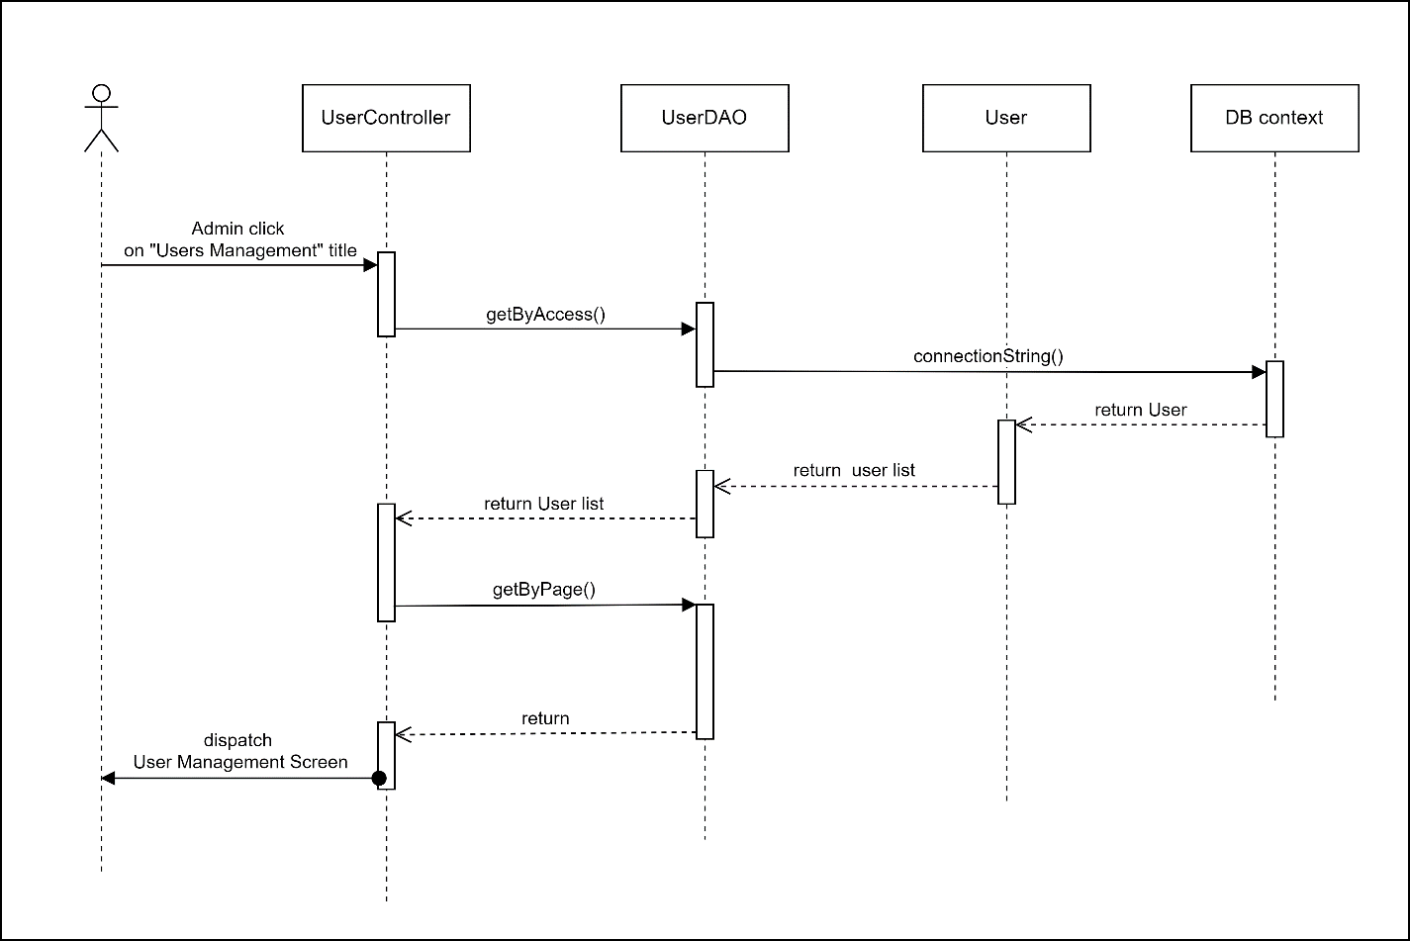

### 

### d. Database queries

Select * from [User] where [is_super] < ?

## 

## 21. View List of User Account

### a. Class Diagram

### 

### b. Class Specifications

#### UserManagement

***Class Methods***

|  |  |  |
| --- | --- | --- |
| **No** | **Method** | **Description** |
| *1* | *doPost()* | *Handles the HTTP <code>POST</code> method.* |

#### LoadUser

***Class Methods***

|  |  |  |
| --- | --- | --- |
| **No** | **Method** | **Description** |
| *1* | *doPost()* | *Handles the HTTP <code>POST</code> method.* |

#### DBContext

***Class Methods***

|  |  |  |
| --- | --- | --- |
| **No** | **Method** | **Description** |
| *1* | *getConnection* | *Method used to connect to the database. Return a <Code>java.sql.Connection</Code> represents a connection to the database.* |

#### UserDAO

***Class Methods***

|  |  |  |
| --- | --- | --- |
| **No** | **Method** | **Description** |
| *1* | *getByAccess ()* | *Method used to return the list of user accounts with lower level than admin account login .Inputs are admin level .Return a List of <Code>model.User</Code> represents the user’s data* |
| *2* | *editRank()* | *Method used to increase or decrease the level of an user account .*  *Input is the id of the user.* |
| *3* | *disableUser()* | *Method used to set the account level lowest . Input is the id of the user.* |
| *4* | *searchByName()* | *Method used to search accounts have the detail has the similarities with text input . Input are the admin level , text need to search . Return a List of <Code>model.User</Code> represents the user’s data* |
| *5* | *sortUser()* | *Method used to sort accounts depend on title . Input are the admin level , title type . Return a List of <Code>model.User</Code> represents the user’s data* |

### c. Sequence Diagram(s)

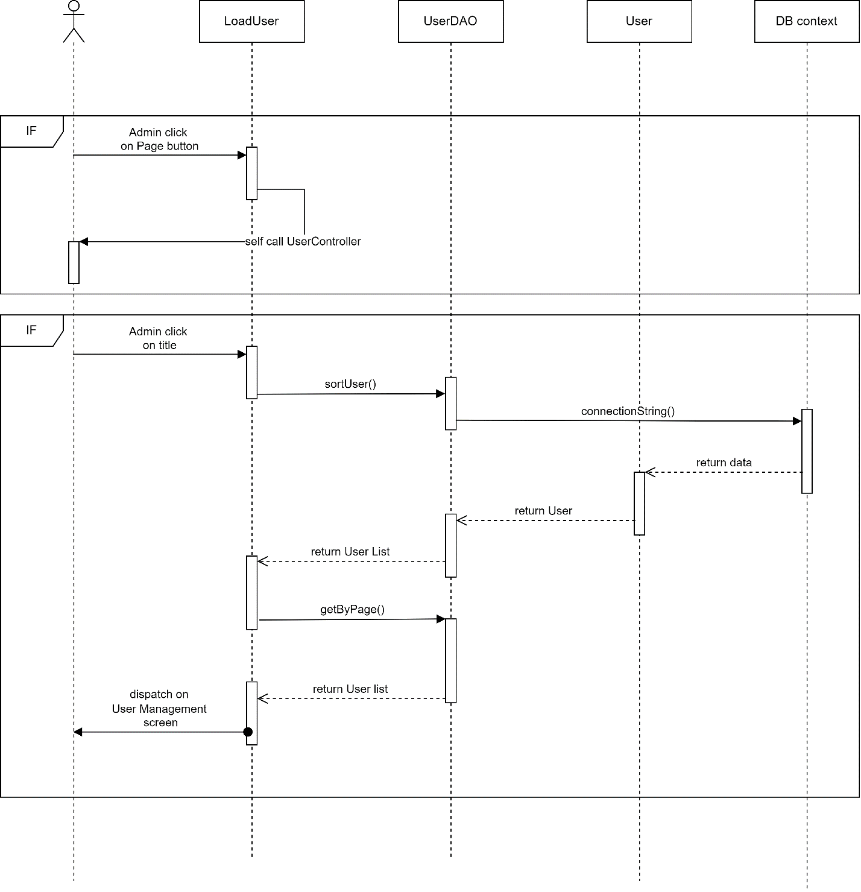

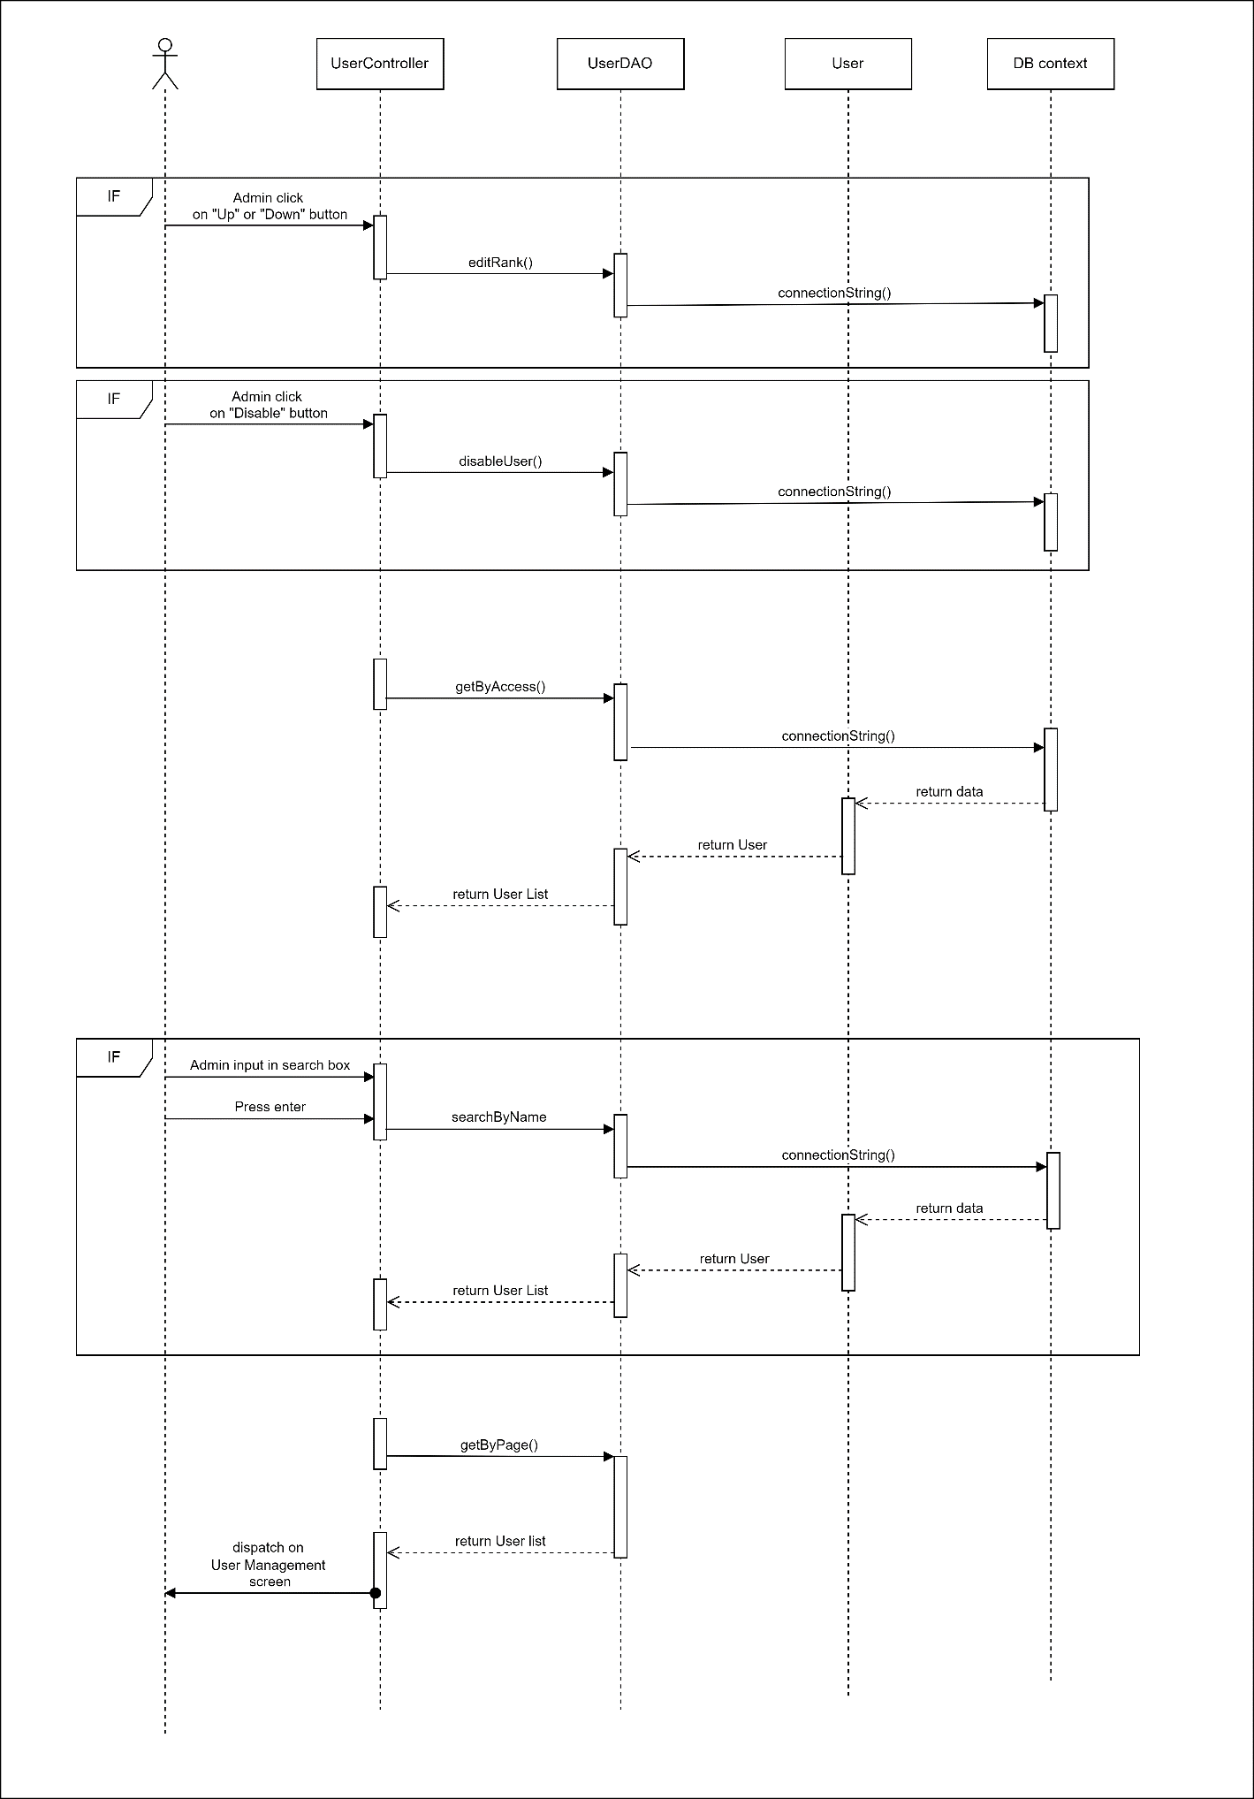

### 

### d. Database queries

getByAccess() : Select * from [User] where [is_super] < ?

disableUser() : update [User] set [is_super] = 0 where [id] = ?

editRank() : update [User] set [is_super] = ? where [id] = ?

searchByName(): select * from [User] where [is_super] < ?

and [fullname] like ?

or [username] like ?

or [email] like ?

or [phone] like ?

or [address] like ?;

sortUser(): select * from [User] where is_super < ? order by ?

## 22. Reading interface

### a. Class Diagram

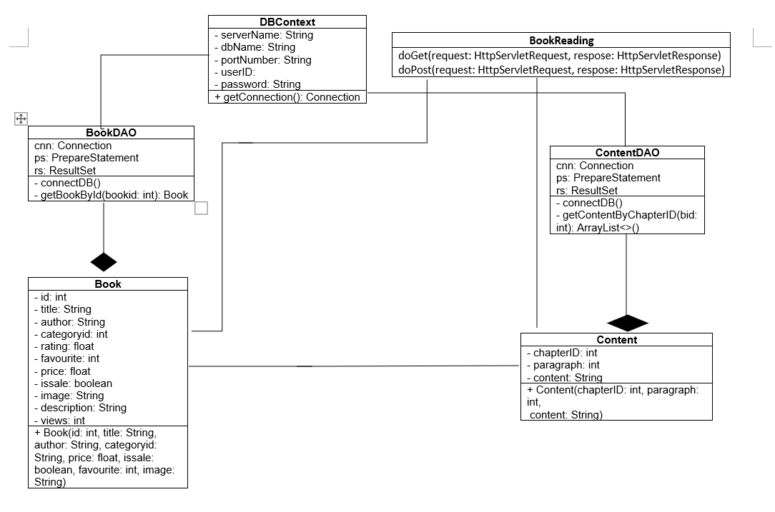

### b. Class Specifications

|  |  |  |
| --- | --- | --- |
| No | Method | Description |
| 01 | Book(int id, String title, String author, float price, boolean issale, int favourite, String image) | Get general information of a books for display on homepage |

**- Book class**

**- DBContext class**

|  |  |  |
| --- | --- | --- |
| No | Method | Description |
| 01 | getConnection() | Connecting with database |

**- BookDAO class**

|  |  |  |
| --- | --- | --- |
| No | Method | Description |
| 01 | getBookByBookId(bookid: int) | Get general information of a book by its BookID |

**- ContentDAO class**

|  |  |  |
| --- | --- | --- |
| No | Method | Description |
| 01 | connectDB() | Connecting with database |
| 02 | getContentByChapterID | Get information of Content by ChapterID |

**- Content class**

|  |  |  |
| --- | --- | --- |
| No | Method | Description |
| 01 | Content(chapterID: int, paragraph: int, content: String) |  |

**- BookReading class**

|  |  |  |
| --- | --- | --- |
| No | Method | Description |
| 01 | doGet() | Handles the HTTP <code>GET</code> method. |
| 02 | doPost() | Handles the HTTP <code>GET</code> method. |

### c. Sequence Diagram(s)

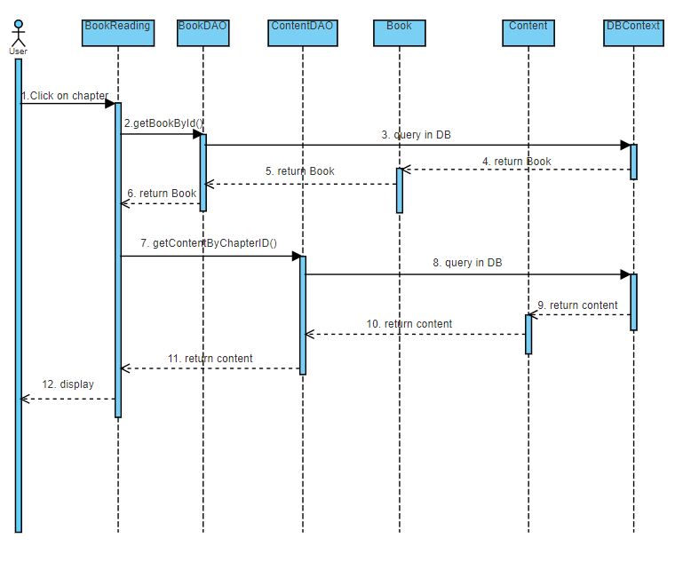

### d. Database queries

- getBookById(bookid: int): "select * from [Book] where [id] = ?"

- getContentByChapterID(bid: int): "select * from Content where chapterId = ?"

## 23. Pre-read

### a. Class Diagram

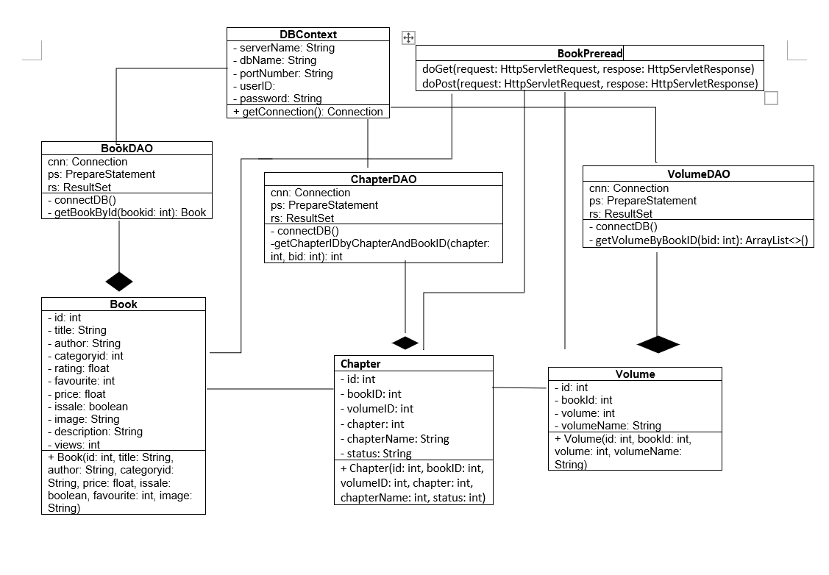

### b. Class Specifications

**- Book class**

|  |  |  |
| --- | --- | --- |
| No | Method | Description |
| 01 | Book(int id, String title, String author, float price, boolean issale, int favourite, String image) | Get general information of book |

**- BookDAO class**

|  |  |  |
| --- | --- | --- |
| No | Method | Description |
| 01 | connectDB() | Connect database |
| 02 | Book(id: int, author: String, categoryid: String, price: float, issale: boolean, image: String ) | Get general information of a book |

**- DBContext class**

|  |  |  |
| --- | --- | --- |
| No | Method | Description |
| 01 | getConnection() | Connecting with database |

**- ChapterDAO class**

|  |  |  |
| --- | --- | --- |
| No | Method | Description |
| 01 | connectDB() | Connect database |
| 02 | getChapterIDbyChapterAndBookID | Get the first chapter of a book |

**- Chapter class**

|  |  |  |
| --- | --- | --- |
| No | Method | Description |
| 01 | Chapter(id: int, bookID: int, volumeID: int, chapter: int, chapterName: int, status: int) | Get information of a chapter |

**- VolumeDAO class**

|  |  |  |
| --- | --- | --- |
| No | Method | Description |
| 01 | connectDB() | Connect database |
| 02 | getVolumeByBookID(bid: int) | Get all volumes of a book by its bookID |

**- VolumeDAO class**

|  |  |  |
| --- | --- | --- |
| No | Method | Description |
| 01 | Volume(id: int, bookid: int, volume: int, volumeName: String) |  |

**- BookPreread class**

|  |  |  |
| --- | --- | --- |
| No | Method | Description |
| 01 | doGet() | Handles the HTTP <code>GET</code> method. |
| 02 | doPost() | Handles the HTTP <code>GET</code> method. |

### c. Sequence Diagram(s)

*[Provide the sequence diagram(s) for the feature, see the sample below]*

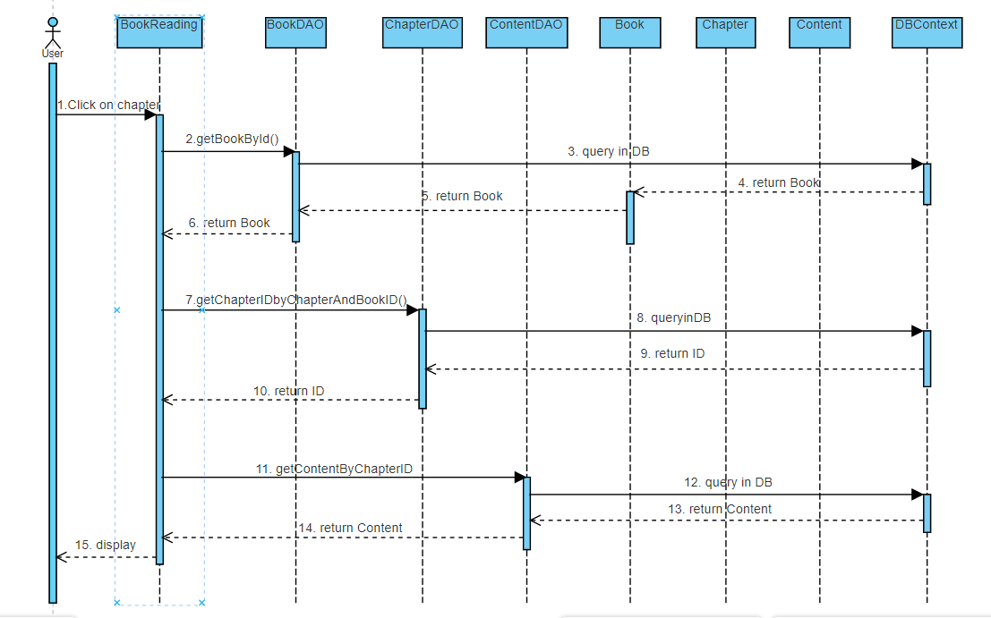

### d. Database queries

- getBookById(bookid: int): "select * from [Book] where [id] = ?"

- getChapterIDByChapterAndBookID(chapter: int, bid: int): “select c.id from Chapter c where chapter = ? and bookId = ?”

- getContentByChapterID(bid: int): "select * from Content where chapterId = ?"

## 24. Table of Contents

### a. Class Diagram

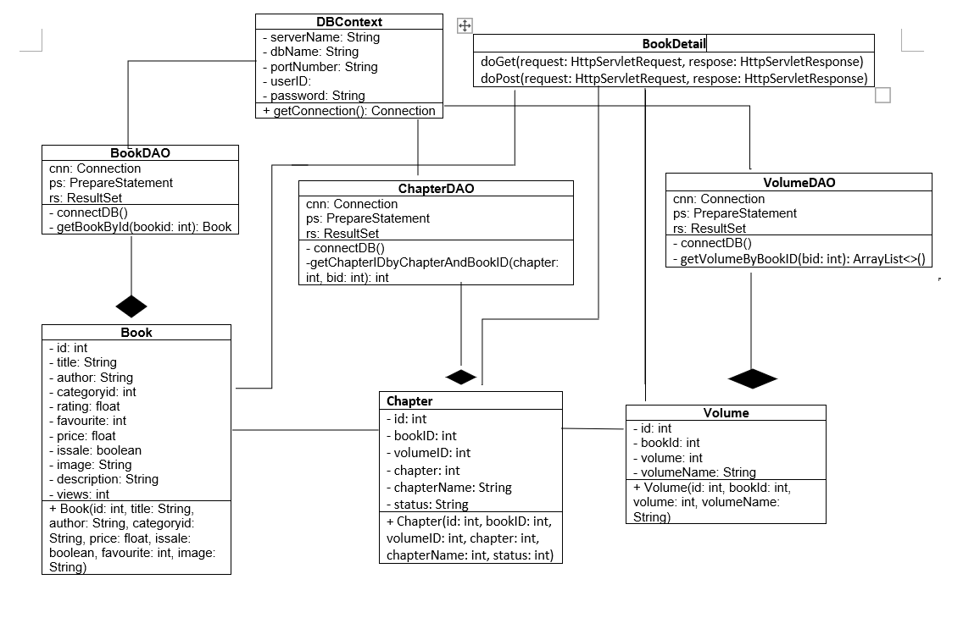

### b. Class Specifications

**- Book class**

|  |  |  |
| --- | --- | --- |
| No | Method | Description |
| 01 | Book(int id, String title, String author, float price, boolean issale, int favourite, String image) | Get general information of book |

**- BookDAO class**

|  |  |  |
| --- | --- | --- |
| No | Method | Description |
| 01 | connectDB() | Connect database |
| 02 | Book(id: int, author: String, categoryid: String, price: float, issale: boolean, image: String ) | Get general information of a book |

**- DBContext class**

|  |  |  |
| --- | --- | --- |
| No | Method | Description |
| 01 | getConnection() | Connecting with database |

**- ChapterDAO class**

|  |  |  |
| --- | --- | --- |
| No | Method | Description |
| 01 | connectDB() | Connect database |
| 02 | getChapterIDbyChapterAndBookID | Get the first chapter of a book |

**- Chapter class**

|  |  |  |
| --- | --- | --- |
| No | Method | Description |
| 01 | Chapter(id: int, bookID: int, volumeID: int, chapter: int, chapterName: int, status: int) | Get information of a chapter |

**- VolumeDAO class**

|  |  |  |
| --- | --- | --- |
| No | Method | Description |
| 01 | connectDB() | Connect database |
| 02 | getVolumeByBookID(bid: int) | Get all volumes of a book by its bookID |

**- VolumeDAO class**

|  |  |  |
| --- | --- | --- |
| No | Method | Description |
| 01 | Volume(id: int, bookid: int, volume: int, volumeName: String) |  |

**- BookDetails class**

|  |  |  |
| --- | --- | --- |
| No | Method | Description |
| 01 | doGet() | Handles the HTTP <code>GET</code> method. |
| 02 | doPost() | Handles the HTTP <code>GET</code> method. |

### c. Sequence Diagram(s)

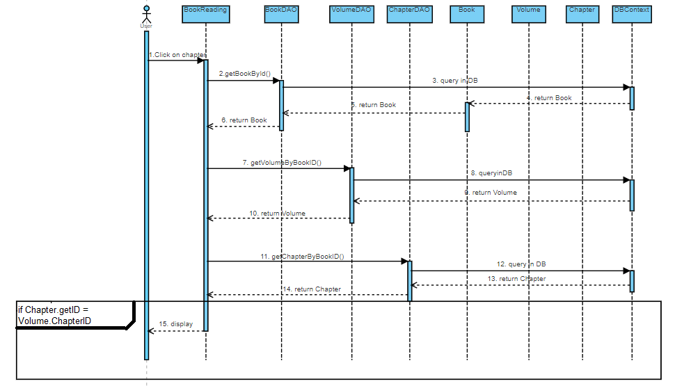

### d. Database queries

- getBookById(bookid: int): "select * from [Book] where [id] = ?"

- getVolumeByBookID(bid: int): ”select * from [Volume] where [bookId] = ?”

- getChapterByBookID(bid: int): "select * from [Chapter] where [bookId] = ?"

## 25. Wallet

### a. Class Diagram

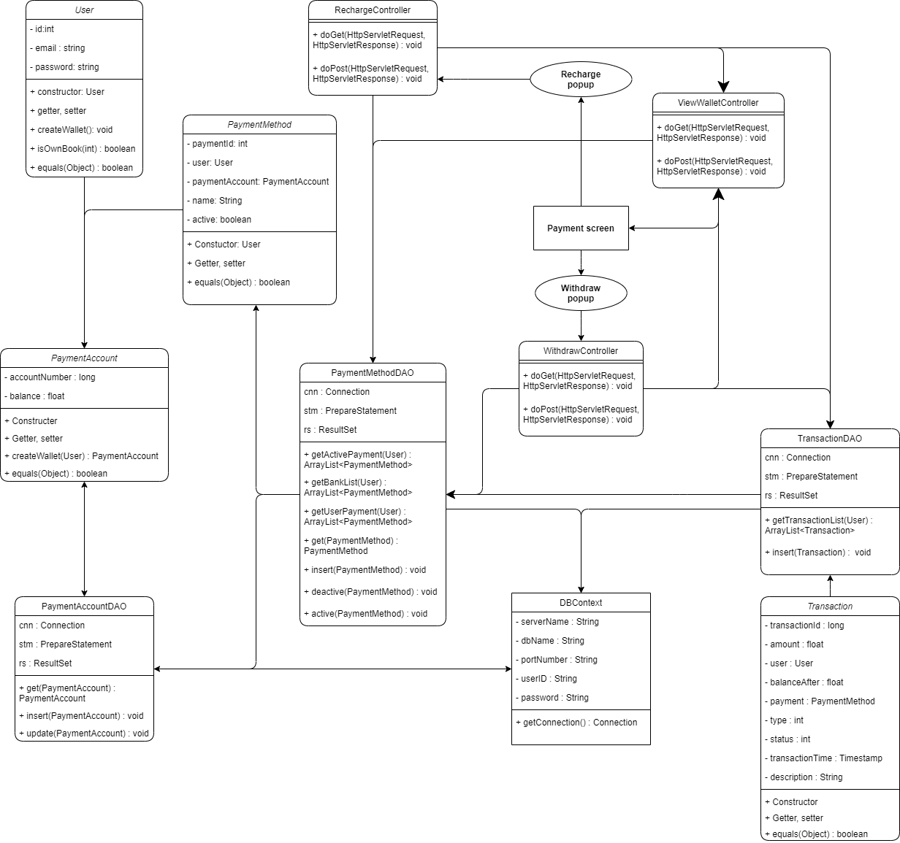

### b. Class Specifications

#### ViewWalletController class

|  |  |  |
| --- | --- | --- |
| **No** | **Method** | **Description** |
| 01 | doGet | Handles the HTTP <code>GET</code> method. |
| 02 | doPost | Handles the HTTP <code>POST</code> method. |

#### RechargeController class

|  |  |  |
| --- | --- | --- |
| **No** | **Method** | **Description** |
| 01 | doGet | Handles the HTTP <code>GET</code> method. |
| 02 | doPost | Handles the HTTP <code>POST</code> method. |

#### WithdrawController class

|  |  |  |
| --- | --- | --- |
| **No** | **Method** | **Description** |
| 01 | doGet | Handles the HTTP <code>GET</code> method. |
| 02 | doPost | Handles the HTTP <code>POST</code> method. |

#### User class

|  |  |  |
| --- | --- | --- |
| **No** | **Method** | **Description** |
| 01 | getPaymentAccount | Get wallet of user |
| 02 | getId | Get ID of user |
| 03 | createWallet | Create new wallet for new signup user |
| 04 | getPassword | Get password of user |
| 05 | setPaymentAccount | Set payment account as wallet of user |

#### PaymentAccount class

|  |  |  |
| --- | --- | --- |
| **No** | **Method** | **Description** |
| 01 | createWallet | Create new wallet of user |
| 02 | setAccountNumber | Set number as account number of payment account |
| 03 | getAccountNumber | Get account number of payment account |
| 04 | getBalance | Get balance of payment account |
| 05 | setBalance | Set number as balance of payment account |

#### PaymentMethod class

|  |  |  |
| --- | --- | --- |
| **No** | **Method** | **Description** |
| 01 | getPaymentId | Get ID of payment method |
| 02 | setPaymentId | Set ID of payment method |
| 03 | isActive | Check is payment method is active |
| 04 | setActive | Set status of payment method is active or not |
| 05 | getName | Get name of payment method |
| 06 | setName | Set name for payment method |
| 07 | setUser | Set user who own this payment method |
| 08 | getUser | Get user who own this payment pethod |
| 09 | getPaymentAccount | Get payment account which linked in this payment method |
| 10 | setPaymentAccount | Set payment account which linked in this payment method |

#### Transaction class

|  |  |  |
| --- | --- | --- |
| **No** | **Method** | **Description** |
| 01 | getTransactionId | Get ID of transaction |
| 02 | setTransactionId | Set ID for transaction |
| 03 | getAmount | Get amount of transaction |
| 04 | setAmount | Set amount for transaction |
| 05 | getPayment | Get payment method of transaction |
| 06 | setPayment | Set payment method for transaction |
| 07 | getBalanceAfter | Get balance in wallet after transaction finish |
| 08 | setBalanceAfter | Set balance in wallet after transaction finish |
| 09 | getUser | Get user who have this transaction |
| 10 | setUser | Set user as who have this transaction |
| 11 | getType | Get type of transaction |
| 12 | setType | Set type of transaction |
| 13 | getStatus | Get status of transaction |
| 14 | setStatus | Set status of transaction |
| 15 | getTransactionTime | Get time created transaction |
| 16 | setTransactionTime | Set time as created time of transaction |
| 17 | getDescription | Get description of transaction |
| 18 | setDescription | Set description of transaction |

#### TransactionDAO class

|  |  |  |
| --- | --- | --- |
| **No** | **Method** | **Description** |
| 01 | getTransactionList | Get all transaction of user from database |
| 02 | insert | Add new transaction into database tabe of transaction |

#### PaymentMethodDAO class

|  |  |  |
| --- | --- | --- |
| **No** | **Method** | **Description** |
| 01 | deactive | Set payment method as not active in database |
| 02 | get | Get payment method from database base on paymentId or user and paymentAccount |
| 03 | active | Set payment method as active in database |
| 04 | getActivePayment | Get list of all active payment methods of user |
| 05 | getBankList | Get list of all payment methods of user except user’s wallet |
| 06 | insert | Add new payment method into database |

#### UserDAO class

|  |  |  |
| --- | --- | --- |
| **No** | **Method** | **Description** |
| 01 | setWalletNumber | Set account number of payment account as wallet number of user in database |

#### PaymentAccountDAO class

|  |  |  |
| --- | --- | --- |
| **No** | **Method** | **Description** |
| 01 | get | Get payment account from database base on account number |
| 02 | getWallet | Get payment account which is input user’s wallet |
| 03 | insert | Add new payment account into database |
| 04 | update | Update balance of payment account in database |

### c. Sequence Diagram(s)

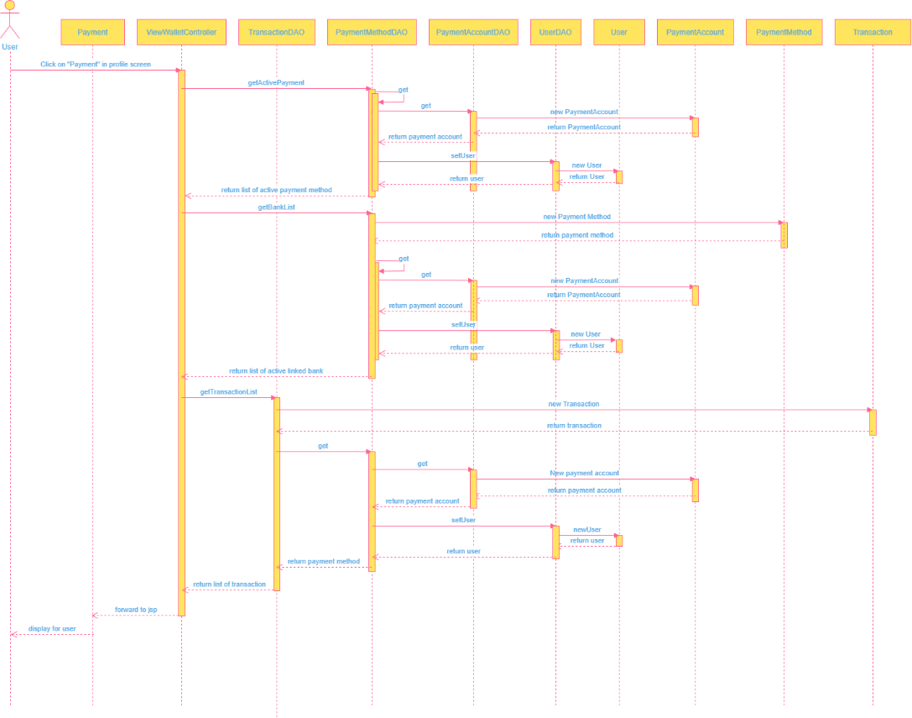

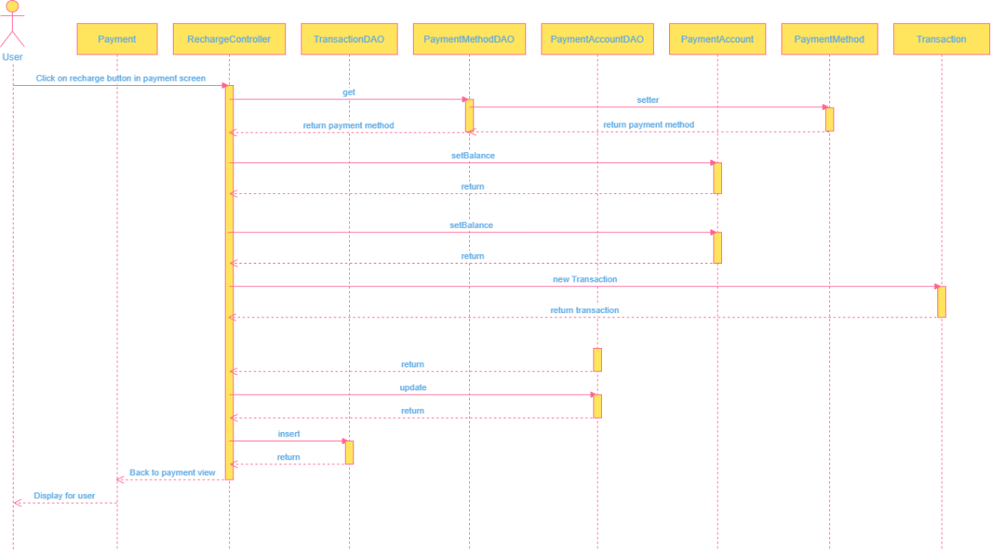

### d. Database queries

UPDATE [Payment_Account]

SET [balance] = ?

WHERE [accountNumber] = ?

INSERT INTO [Transaction

([userId]

,[amount]

,[balanceAfter]

,[type]

,[status]

,[description]

,[paymentId]

,[transactionTime])

VALUES

(? ,? ,?,?,?,?,?,?)

select pa.accountNumber, balance, paymentId, userId, pm.[name]

from Payment_Account pa

inner join Payment_Method pm

on pa.accountNumber = pm.accountNumber

where pa.accountNumber not in

(select walletNumber from [User]

inner join Payment_Account

on [User].walletNumber = Payment_Account.accountNumber

) and userId = ?

SELECT paymentId, userId, pm.accountNumber, [name], [balance], [active]

FROM Payment_Method pm inner join Payment_Account pa

ON pm.accountNumber = pa.accountNumber

WHERE userId = ?

AND [active] = 1

## 26. Payment

### a. Class Diagram

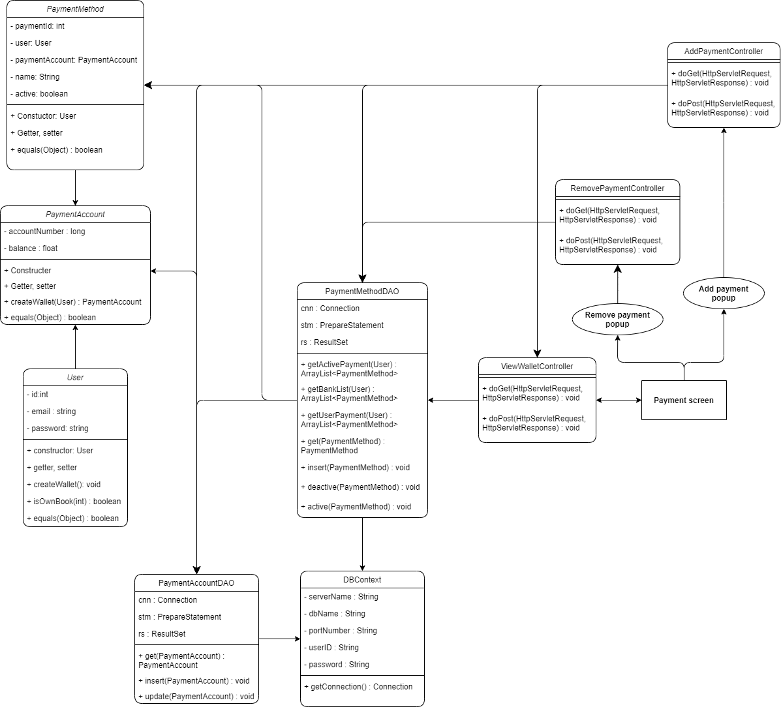

#### b, Class Specification

#### ViewWalletController class

|  |  |  |
| --- | --- | --- |
| **No** | **Method** | **Description** |
| 01 | doGet | Handles the HTTP <code>GET</code> method. |
| 02 | doPost | Handles the HTTP <code>POST</code> method. |

#### AddPaymentController class

|  |  |  |
| --- | --- | --- |
| **No** | **Method** | **Description** |
| 01 | doGet | Handles the HTTP <code>GET</code> method. |
| 02 | doPost | Handles the HTTP <code>POST</code> method. |

#### RemovePaymentController class

|  |  |  |
| --- | --- | --- |
| **No** | **Method** | **Description** |
| 01 | doGet | Handles the HTTP <code>GET</code> method. |
| 02 | doPost | Handles the HTTP <code>POST</code> method. |

#### User class

|  |  |  |
| --- | --- | --- |
| **No** | **Method** | **Description** |
| 01 | getPaymentAccount | Get wallet of user |
| 02 | getId | Get ID of user |
| 03 | createWallet | Create new wallet for new signup user |
| 04 | getPassword | Get password of user |
| 05 | setPaymentAccount | Set payment account as wallet of user |

#### PaymentAccount class

|  |  |  |
| --- | --- | --- |
| **No** | **Method** | **Description** |
| 01 | createWallet | Create new wallet of user |
| 02 | setAccountNumber | Set number as account number of payment account |
| 03 | getAccountNumber | Get account number of payment account |
| 04 | getBalance | Get balance of payment account |
| 05 | setBalance | Set number as balance of payment account |

#### PaymentMethod class

|  |  |  |
| --- | --- | --- |
| **No** | **Method** | **Description** |
| 01 | getPaymentId | Get ID of payment method |
| 02 | setPaymentId | Set ID of payment method |
| 03 | isActive | Check is payment method is active |
| 04 | setActive | Set status of payment method is active or not |
| 05 | getName | Get name of payment method |
| 06 | setName | Set name for payment method |
| 07 | setUser | Set user who own this payment method |
| 08 | getUser | Get user who own this payment pethod |
| 09 | getPaymentAccount | Get payment account which linked in this payment method |
| 10 | setPaymentAccount | Set payment account which linked in this payment method |

#### Context.TransactionDAO

|  |  |  |
| --- | --- | --- |
| **No** | **Method** | **Description** |
| 01 | getTransactionList | Get all transaction of user from database |
| 02 | insert | Add new transaction into database table of transaction |

#### Transaction class

|  |  |  |
| --- | --- | --- |
| **No** | **Method** | **Description** |
| 01 | getTransactionId | Get ID of transaction |
| 02 | setTransactionId | Set ID for transaction |
| 03 | getAmount | Get amount of transaction |
| 04 | setAmount | Set amount for transaction |
| 05 | getPayment | Get payment method of transaction |
| 06 | setPayment | Set payment method for transaction |
| 07 | getBalanceAfter | Get balance in wallet after transaction finish |
| 08 | setBalanceAfter | Set balance in wallet after transaction finish |
| 09 | getUser | Get user who have this transaction |
| 10 | setUser | Set user as who have this transaction |
| 11 | getType | Get type of transaction |
| 12 | setType | Set type of transaction |
| 13 | getStatus | Get status of transaction |
| 14 | setStatus | Set status of transaction |
| 15 | getTransactionTime | Get time created transaction |
| 16 | setTransactionTime | Set time as created time of transaction |
| 17 | getDescription | Get description of transaction |
| 18 | setDescription | Set description of transaction |

#### PaymentMethodDAO class

|  |  |  |
| --- | --- | --- |
| **No** | **Method** | **Description** |
| 01 | deactive | Set payment method as not active in database |
| 02 | get | Get payment method from database base on paymentId or user and paymentAccount |
| 03 | active | Set payment method as active in database |
| 04 | getActivePayment | Get list of all active payment methods of user |
| 05 | getBankList | Get list of all payment methods of user except user’s wallet |
| 06 | insert | Add new payment method into database |

### c. Sequence Diagram(s)

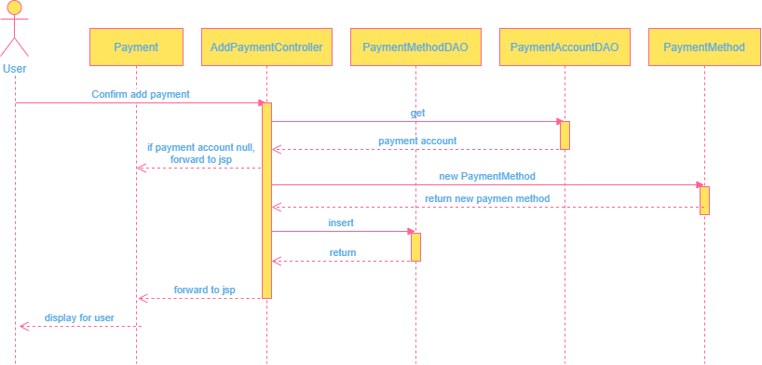

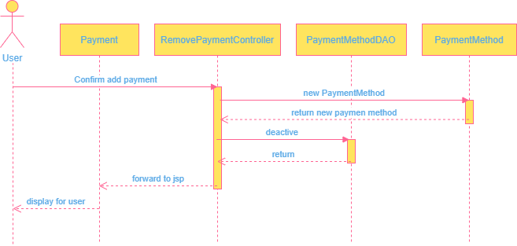

### d. Database queries

INSERT INTO [Payment_Method]

([userId]

,[accountNumber]

,[name]

,[active])

VALUES (?, ?, ?, ?)

UPDATE [dbo].[Payment_Method]

SET [active] = 0

WHERE paymentId = ?

## 27. View purchase history

### a. Class Diagram

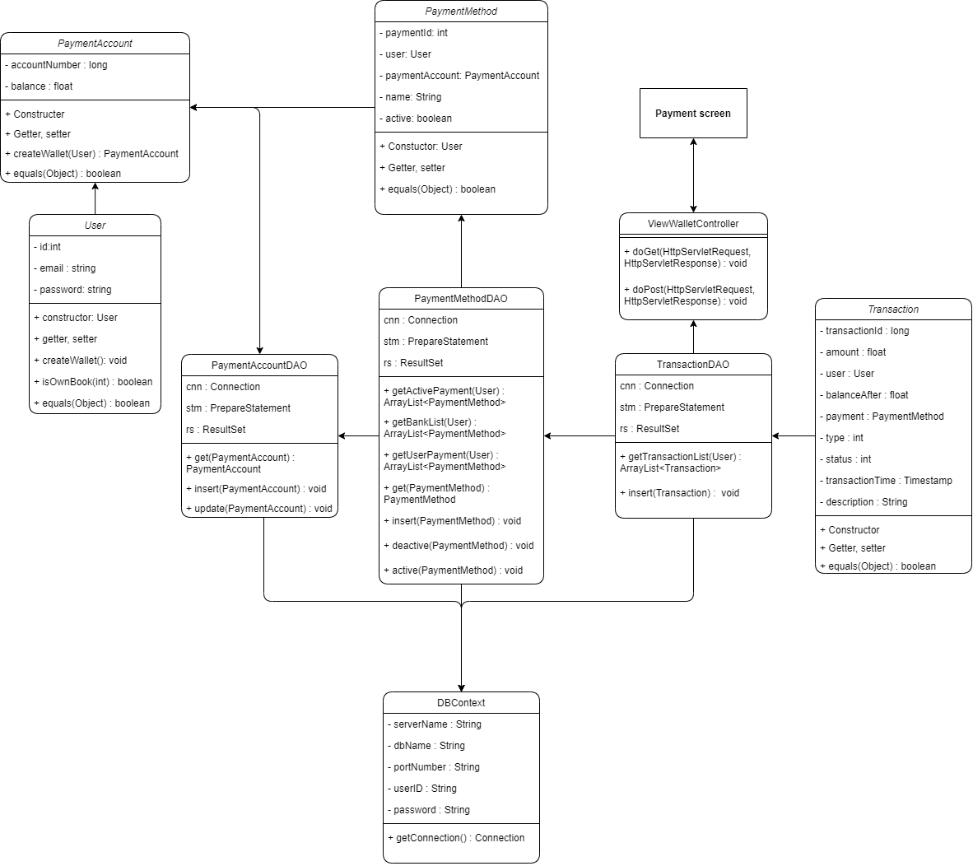

### b. Class Specifications

#### ViewWalletController class

|  |  |  |
| --- | --- | --- |
| **No** | **Method** | **Description** |
| 01 | doGet | Handles the HTTP <code>GET</code> method. |
| 02 | doPost | Handles the HTTP <code>POST</code> method. |

#### PaymentAccount class

|  |  |  |
| --- | --- | --- |
| **No** | **Method** | **Description** |
| 01 | createWallet | Create new wallet of user |
| 02 | setAccountNumber | Set number as account number of payment account |
| 03 | getAccountNumber | Get account number of payment account |
| 04 | getBalance | Get balance of payment account |
| 05 | setBalance | Set number as balance of payment account |

#### PaymentMethod class

|  |  |  |
| --- | --- | --- |
| **No** | **Method** | **Description** |
| 01 | getPaymentId | Get ID of payment method |
| 02 | setPaymentId | Set ID of payment method |
| 03 | isActive | Check is payment method is active |
| 04 | setActive | Set status of payment method is active or not |
| 05 | getName | Get name of payment method |
| 06 | setName | Set name for payment method |
| 07 | setUser | Set user who own this payment method |
| 08 | getUser | Get user who own this payment pethod |
| 09 | getPaymentAccount | Get payment account which linked in this payment method |
| 10 | setPaymentAccount | Set payment account which linked in this payment method |

#### Transaction class

|  |  |  |
| --- | --- | --- |
| **No** | **Method** | **Description** |
| 01 | getTransactionId | Get ID of transaction |
| 02 | setTransactionId | Set ID for transaction |
| 03 | getAmount | Get amount of transaction |
| 04 | setAmount | Set amount for transaction |
| 05 | getPayment | Get payment method of transaction |
| 06 | setPayment | Set payment method for transaction |
| 07 | getBalanceAfter | Get balance in wallet after transaction finish |
| 08 | setBalanceAfter | Set balance in wallet after transaction finish |
| 09 | getUser | Get user who have this transaction |
| 10 | setUser | Set user as who have this transaction |
| 11 | getType | Get type of transaction |
| 12 | setType | Set type of transaction |
| 13 | getStatus | Get status of transaction |
| 14 | setStatus | Set status of transaction |
| 15 | getTransactionTime | Get time created transaction |
| 16 | setTransactionTime | Set time as created time of transaction |
| 17 | getDescription | Get description of transaction |
| 18 | setDescription | Set description of transaction |

#### TransactionDAO class

|  |  |  |
| --- | --- | --- |
| **No** | **Method** | **Description** |
| 01 | getTransactionList | Get all transaction of user from database |
| 02 | insert | Add new transaction into database tabe of transaction |

#### Context.PaymentMethodDAO

|  |  |  |
| --- | --- | --- |
| **No** | **Method** | **Description** |
| 01 | deactive | Set payment method as not active in database |
| 02 | get | Get payment method from database base on paymentId or user and paymentAccount |
| 03 | active | Set payment method as active in database |
| 04 | getActivePayment | Get list of all active payment methods of user |
| 05 | getBankList | Get list of all payment methods of user except user’s wallet |
| 06 | insert | Add new payment method into database |

### c. Sequence Diagram(s)

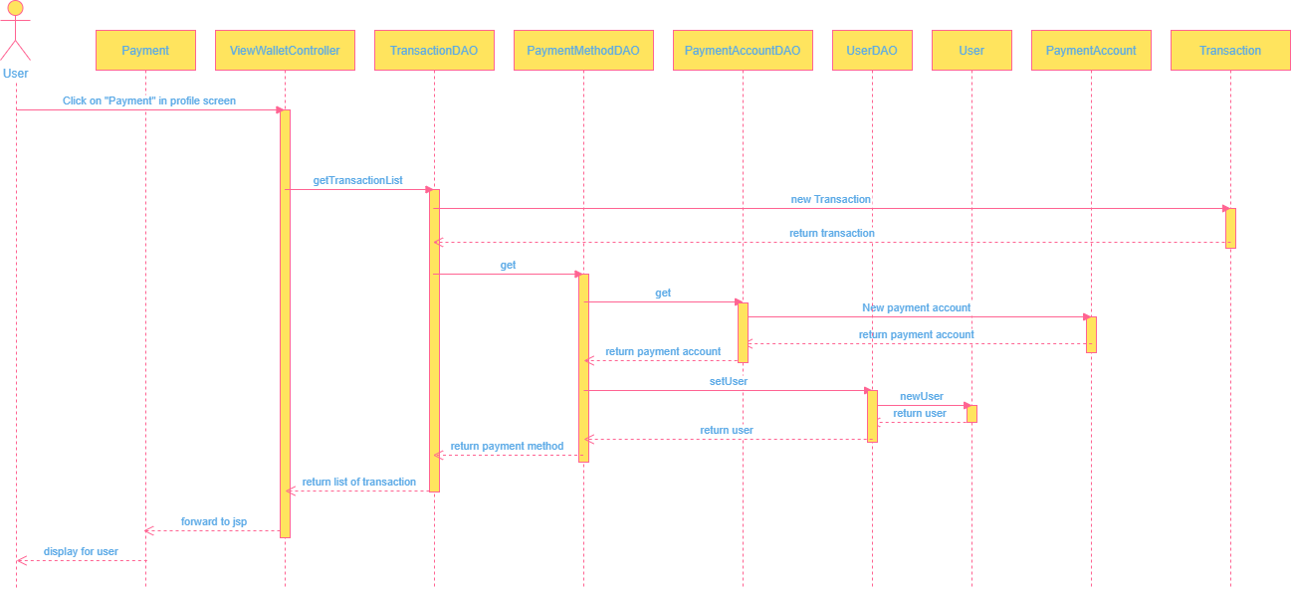

### d. Database queries

SELECT [transactionId

,[userId]

,[amount]

,[balanceAfter]

,[transactionTime]

,[type]

,[status]

,[description]

,[paymentId]

FROM [Transaction]

WHERE userId = ?

ORDER BY transactionTime desc

## 28. Purchase a book

### Class Diagram

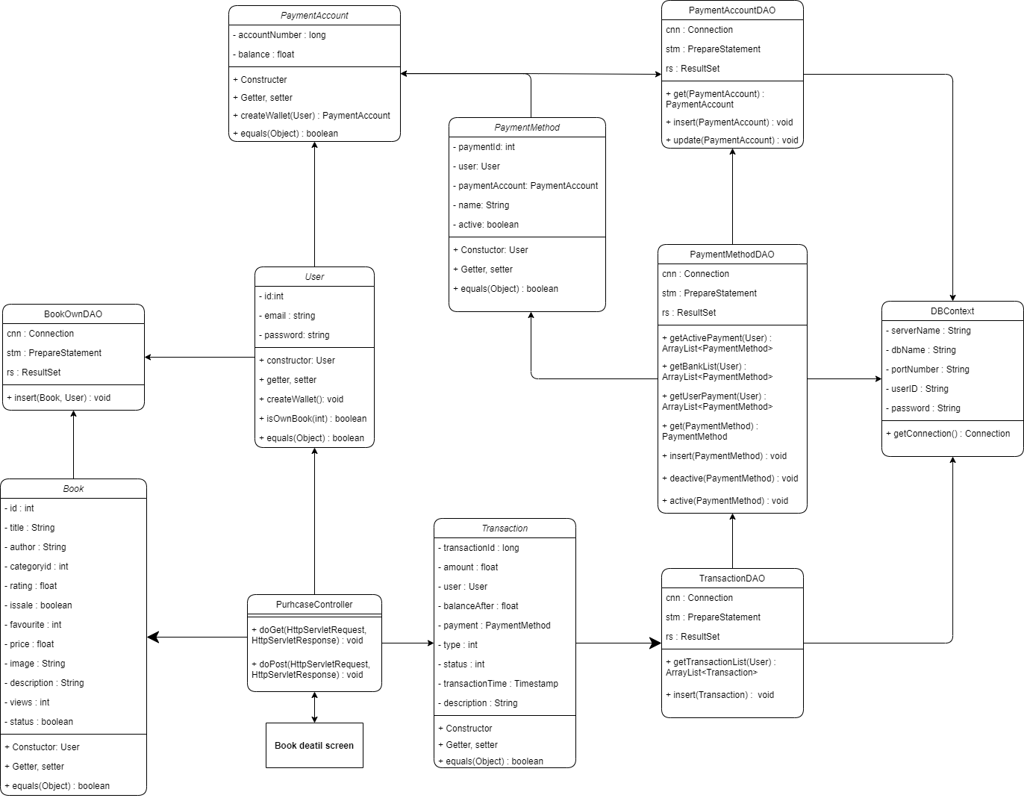

### b. Class Specifications

#### PaymentAccount class

|  |  |  |
| --- | --- | --- |
| **No** | **Method** | **Description** |
| 01 | createWallet | Create new wallet of user |
| 02 | setAccountNumber | Set number as account number of payment account |
| 03 | getAccountNumber | Get account number of payment account |
| 04 | getBalance | Get balance of payment account |
| 05 | setBalance | Set number as balance of payment account |

#### PaymentMethod class

|  |  |  |
| --- | --- | --- |
| **No** | **Method** | **Description** |
| 01 | getPaymentId | Get ID of payment method |
| 02 | setPaymentId | Set ID of payment method |
| 03 | isActive | Check is payment method is active |
| 04 | setActive | Set status of payment method is active or not |
| 05 | getName | Get name of payment method |
| 06 | setName | Set name for payment method |
| 07 | setUser | Set user who own this payment method |
| 08 | getUser | Get user who own this payment pethod |
| 09 | getPaymentAccount | Get payment account which linked in this payment method |
| 10 | setPaymentAccount | Set payment account which linked in this payment method |

#### User class

|  |  |  |
| --- | --- | --- |
| **No** | **Method** | **Description** |
| 01 | getId | Get ID of user |
| 02 | getPaymentAccount | Get wallet of user |
| 03 | setPaymentAccount | Set payment account as wallet of user |

#### Book class

|  |  |  |
| --- | --- | --- |
| **No** | **Method** | **Description** |
| 01 | getId | Get ID of book |
| 02 | getTitle | Get title of book |
| 03 | getPrice | Get price of book |

#### Transaction class

|  |  |  |
| --- | --- | --- |
| **No** | **Method** | **Description** |
| 01 | getTransactionId | Get ID of transaction |
| 02 | setTransactionId | Set ID for transaction |
| 03 | getAmount | Get amount of transaction |
| 04 | setAmount | Set amount for transaction |
| 05 | getPayment | Get payment method of transaction |
| 06 | setPayment | Set payment method for transaction |
| 07 | getBalanceAfter | Get balance in wallet after transaction finish |
| 08 | setBalanceAfter | Set balance in wallet after transaction finish |
| 09 | getUser | Get user who have this transaction |
| 10 | setUser | Set user as who have this transaction |
| 11 | getType | Get type of transaction |
| 12 | setType | Set type of transaction |
| 13 | getStatus | Get status of transaction |
| 14 | setStatus | Set status of transaction |
| 15 | getTransactionTime | Get time created transaction |
| 16 | setTransactionTime | Set time as created time of transaction |
| 17 | getDescription | Get description of transaction |
| 18 | setDescription | Set description of transaction |

#### BookDAO class

|  |  |  |
| --- | --- | --- |
| **No** | **Method** | **Description** |
| 01 | isOwn | Check if user own this book |
| 02 | getOwnBooks | Get all books that user own |
| 03 | getBookById | Get a book by it’s ID |

#### BookOwnDAO class

|  |  |  |
| --- | --- | --- |
| **No** | **Method** | **Description** |
| 01 | insert | Add new own status of an user with a book |

#### TransactionDAO class

|  |  |  |
| --- | --- | --- |
| **No** | **Method** | **Description** |
| 01 | getTransactionList | Get all transaction of user from database |
| 02 | insert | Add new transaction into database tabe of transaction |

#### ViewWalletController class

|  |  |  |
| --- | --- | --- |
| **No** | **Method** | **Description** |
| 01 | doGet | Handles the HTTP <code>GET</code> method. |
| 02 | doPost | Handles the HTTP <code>POST</code> method. |

### c. Sequence Diagram(s)

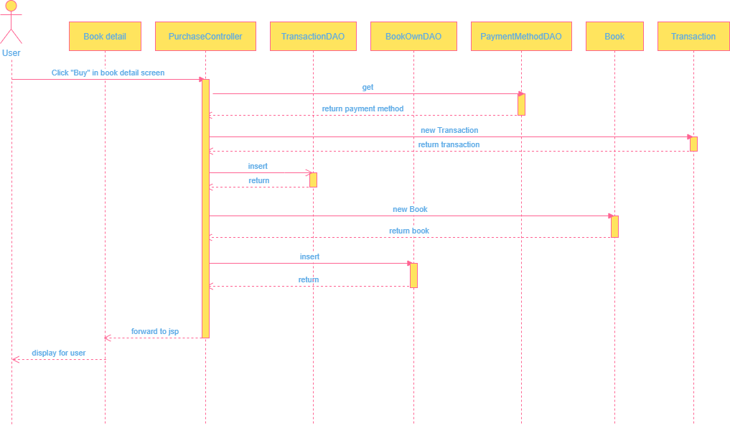

### d. Database queries

select bo.bookId from [User] u

inner join [Book_Own] bo

on bo.userId = u.id

inner join Book b

on bo.bookId = b.id

where u.id = ?

INSERT INTO [Book_Own]

([userId]

,[bookId])

VALUES

(? ,?)

## 29. Change email

### a. Class Diagram

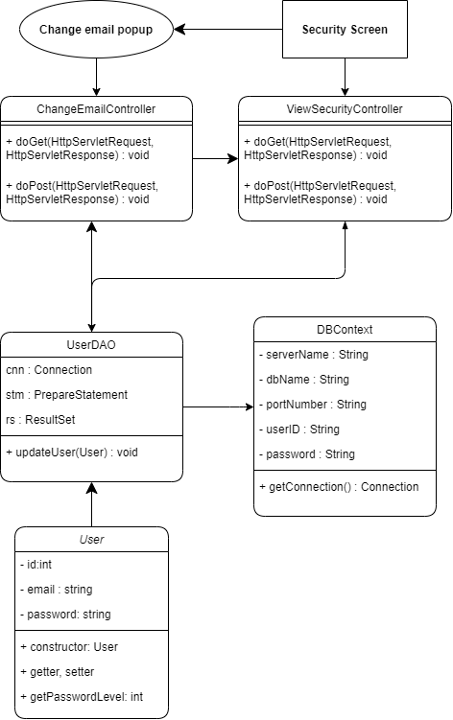

### b. Class Specifications

#### ProfileController class

|  |  |  |
| --- | --- | --- |
| **No** | **Method** | **Description** |
| 01 | doGet | Handles the HTTP <code>GET</code> method. |
| 02 | doPost | Handles the HTTP <code>POST</code> method. |

#### User class

|  |  |  |
| --- | --- | --- |
| **No** | **Method** | **Description** |
| 01 | getId | Get ID of user |
| 02 | getName | Get name of user |
| 03 | getGender | Get gender of user |
| 04 | getPhone | Get phone number of user |
| 05 | getAddress | Get address of user |
| 06 | getEmail | Get email of user |
| 07 | setEmail | Set name of user |

#### UserDAO class

|  |  |  |
| --- | --- | --- |
| **No** | **Method** | **Description** |
| 01 | updateProfile | Update information of user in database |

#### Validator class

|  |  |  |
| --- | --- | --- |
| **No** | **Method** | **Description** |
| 01 | getString | Check if string is empty |
| 02 | getName | Check if name is empty or contains digit or so long |

### c. Sequence Diagram(s)

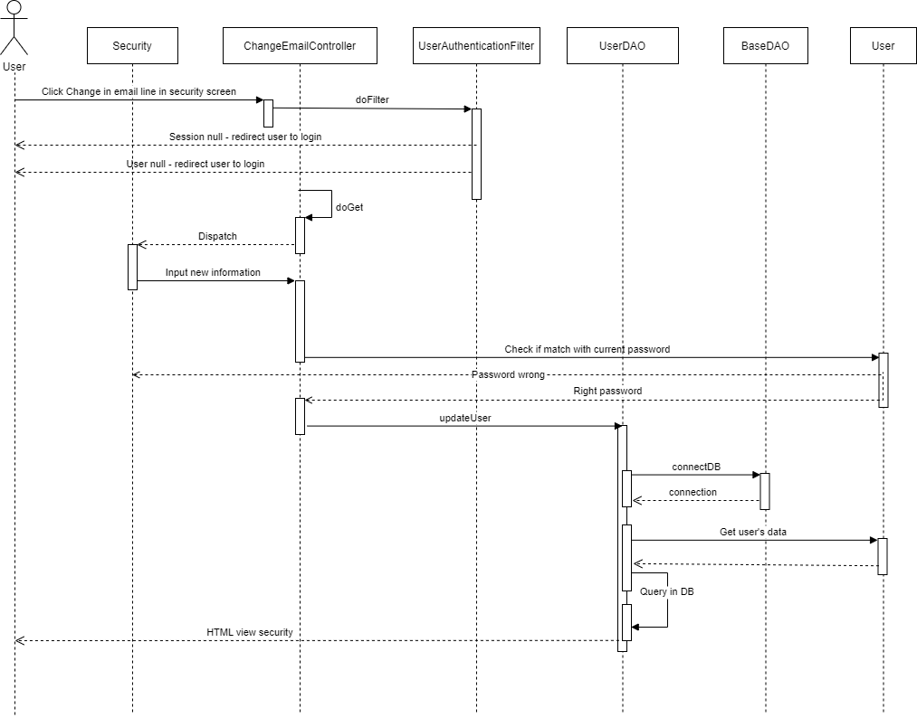

### d. Database queries

update [User] set

[fullname] = ?,[phone] = ?,[address] = ?, [gender] = ?, [dob] = ? ,[email] = ?

where [id] = ?

## 30. Search Engine

**a. Class Diagram**

**b. Class Specifications**

#### BookController

|  |  |  |
| --- | --- | --- |
| **No** | **Method** | **Description** |
| 01 | doGet | Handles the HTTP <code>GET</code> method. |
| 02 | doPost | Handles the HTTP <code>POST</code> method. |

#### BookDAO

|  |  |  |
| --- | --- | --- |
| **No** | **Method** | **Description** |
| 01 | getByPage(books, start, end) | Get books in each page |
| 02 | getBooks(search,author,iCate) | Get all the books that fit the requirements |

#### DBContext

|  |  |  |
| --- | --- | --- |
| **No** | **Method** | **Description** |
| 01 | getConnection() | Get access to the database |

#### CategoryDAO

|  |  |  |
| --- | --- | --- |
| **No** | **Method** | **Description** |
| 01 | getAllCategory() | Get all the category of the books |

**c. Sequence Diagram**

**d. Database queries**

* String sql = "SELECT [Book].[id] as [bookId]\n"

+ " ,[title]\n"

+ " ,[authorId]\n"

+ " ,[Author].[name] as [authorName]\n"

+ " ,[rating]\n"

+ " ,[favourite]\n"

+ " ,[price]\n"

+ " ,[is_sale]\n"

+ " ,[image]\n"

+ " ,[description]\n"

+ " ,[views]\n"

+ " ,[status]\n"

+ " FROM [Book]"

+ " INNER JOIN [Author] ON [Book].[authorId] = [Author].[id]"

+ " INNER JOIN [CategoryBook] cb ON [Book].[id] = cb.[bookId]"

+ " WHERE [Book].[title] LIKE ? "

+ " AND [Author].[name] LIKE ? "

+ " AND [status] != 0 "

+ " AND [Author].[userId] IS NULL";

int idCateLength = idCategory.length;

if (idCategory[0] != -1) {

sql += "AND cb.[categoryId] in (? ";

for (int i = 1; i < idCateLength; i++) {

sql += ",? ";

}

sql += ") GROUP BY [Book].[id]\n"

+ " ,[title]\n"

+ " ,[authorId]\n"

+ " ,[Author].[name]\n"

+ " ,[rating]\n"

+ " ,[favourite]\n"

+ " ,[price]\n"

+ " ,[is_sale]\n"

+ " ,[image]\n"

+ " ,[description]\n"

+ " ,[views]\n"

+ " ,[status]\n"

+ "having count(distinct cb.[categoryId]) = ? ";

} else {

sql += " GROUP BY [Book].[id]\n"

+ " ,[title]\n"

+ " ,[authorId]\n"

+ " ,[Author].[name]\n"

+ " ,[rating]\n"

+ " ,[favourite]\n"

+ " ,[price]\n"

+ " ,[is_sale]\n"

+ " ,[image]\n"

+ " ,[description]\n"

+ " ,[views]\n"

+ " ,[status]\n";

}

* "SELECT [Book].[id]\n"

+ " ,[title]\n"

+ " ,[authorId]\n"

+ " ,[Author].[name]\n"

+ " ,[rating]\n"

+ " ,[favourite]\n"

+ " ,[price]\n"

+ " ,[is_sale]\n"

+ " ,[image]\n"

+ " ,[description]\n"

+ " ,[views]\n"

+ " ,[status]\n"

+ " FROM [Book]"

+ " INNER JOIN [Author] ON [Book].[authorId] = [Author].[id]"

+ " INNER JOIN [CategoryBook] cb ON [Book].[id] = cb.[bookId] "

+ " WHERE cb.[categoryId] = ?"

+ " AND [status] != 0 "

## 31. Paging

**a. Class Diagram**

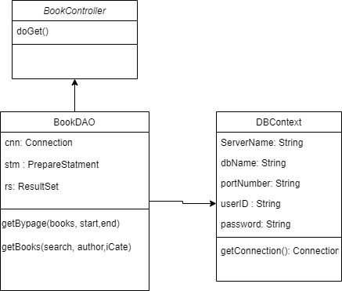

**b. Class Specifications**

#### BookController

|  |  |  |
| --- | --- | --- |
| **No** | **Method** | **Description** |
| 01 | doGet | Handles the HTTP <code>GET</code> method. |
| 02 | doPost | Handles the HTTP <code>POST</code> method. |

#### BookDAO

|  |  |  |
| --- | --- | --- |
| **No** | **Method** | **Description** |
| 01 | getByPage(books, start, end) | Get books in each page |
| 02 | getBooks(search,author,iCate) | Get all the books that fit the requirements |

#### DBContext

|  |  |  |
| --- | --- | --- |
| **No** | **Method** | **Description** |
| 01 | getConnection() | Get access to the database |

**c. Sequence Diagram**

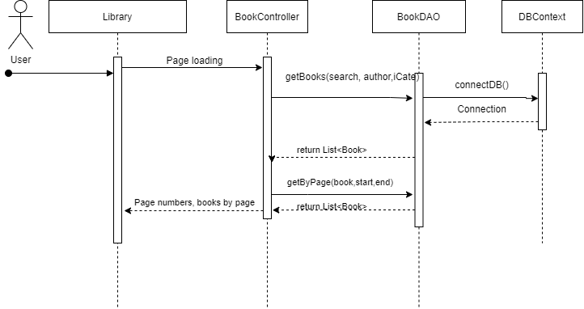

**d. Database queries**

* "SELECT [Book].[id] as [bookId]\n"

+ " ,[title]\n"

+ " ,[authorId]\n"

+ " ,[Author].[name] as [authorName]\n"

+ " ,[rating]\n"

+ " ,[favourite]\n"

+ " ,[price]\n"

+ " ,[is_sale]\n"

+ " ,[image]\n"

+ " ,[description]\n"

+ " ,[views]\n"

+ " ,[status]\n"

+ " FROM [Book]"

+ " INNER JOIN [Author] ON [Book].[authorId] = [Author].[id]"

+ " INNER JOIN [CategoryBook] cb ON [Book].[id] = cb.[bookId]"

+ " WHERE [Book].[title] LIKE ? "

+ " AND [Author].[name] LIKE ? "

+ " AND [status] != 0 "

## 32. Delete From Favourite

**a. Class Diagram**

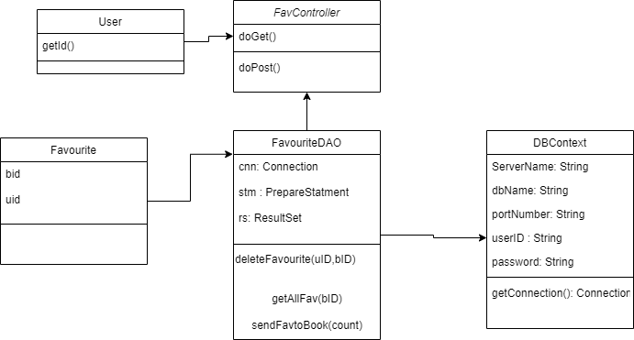

**b. Class Specifications**

#### FavController

|  |  |  |
| --- | --- | --- |
| **No** | **Method** | **Description** |
| 01 | doGet | Handles the HTTP <code>GET</code> method. |
| 02 | doPost | Handles the HTTP <code>POST</code> method. |

#### User

|  |  |  |
| --- | --- | --- |
| **No** | **Method** | **Description** |
| 01 | getId() | Get User ID |

#### FavouriteDAO

|  |  |  |
| --- | --- | --- |
| **No** | **Method** | **Description** |
| 01 | deleteFavourite() | Delete the specific book from the Favourites of the user |
| 02 | getAllFav() | Get all the user that add this book as favourite |
| 03 | sendFavtoBook() | Store the number of users that add this book as favourite to the database |

#### DBContext

|  |  |  |
| --- | --- | --- |
| **No** | **Method** | **Description** |
| 01 | getConnection() | Get access to the database |

**c. Sequence Diagram**

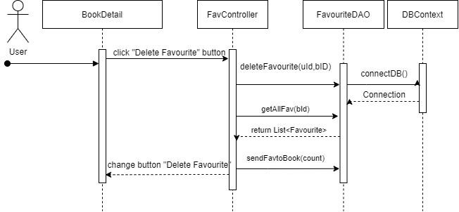

**d. Database queries**

- "DELETE FROM [dbo].[Favourite]\n"

+ " WHERE uid='" + uID + "' and bid='" + bID + "'"

* “SELECT * FROM [Favourite] WHERE bid='" + bID + "'"
* "INSERT INTO [dbo].[Book]\n"
* + " (\n"
* + " [favourite])\n"
* + " VALUES\n"
* + " ('" + count + "'"
* + " )"

## 33.1 View my own novels

### a. Class Diagram

### b. Class Specifications

#### BooksController

***Class Methods***

|  |  |  |
| --- | --- | --- |
| **No** | **Method** | **Description** |
| *1* | *doGet()* | *Handles the HTTP <code>GET</code> method.* |
| *2* | *doPost()* | *Handles the HTTP <code>POST</code> method.* |

#### BookDAO

***Class Methods***

|  |  |  |
| --- | --- | --- |
| **No** | **Method** | **Description** |
| *1* | *getUserNovels* | *Method used to get all novels and its information of specific user in database. Return an array list <Book> represents the data of books.* |
| *2* | *getByPage* | *Method used to divide list of books to many page. Return an array list <Book> represents the data of books.* |

#### CategoryDAO

***Class Methods***

|  |  |  |
| --- | --- | --- |
| **No** | **Method** | **Description** |
| *1* | *getAllCategory* | *Method used to get all category and its information in database. Return an array list <Category> represents the data of books.* |
| *2* | *getCategoriesBook* | *Method used to get all genres of a book in database. Return an array list <Category>* |

#### DBContext

***Class Methods***

|  |  |  |
| --- | --- | --- |
| **No** | **Method** | **Description** |
| *1* | *getConnection* | *Method used to connect to the database. Return a <Code>java.sql.Connection</Code> represents a connection to the database.* |

### c. Sequence Diagram(s)

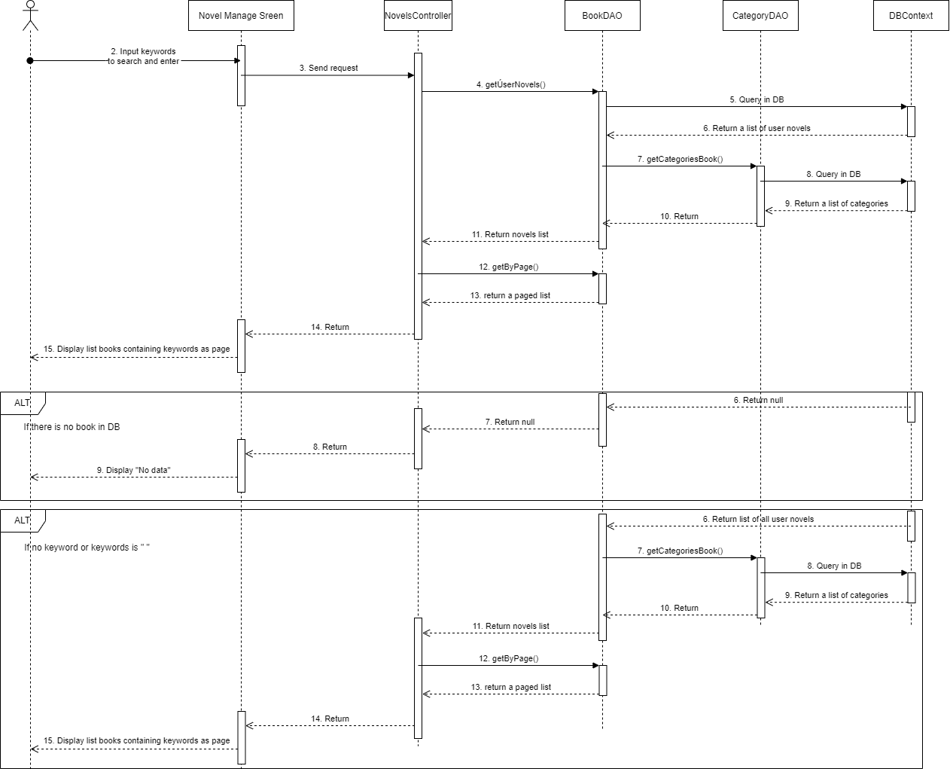

### d. Data queries

1. getUserNovels

SELECT [Book].[id]

,[title]

,[authorId]

,[Author].[name]

,[rating]

,[favourite]

,[price]

,[is_sale]

,[image]

,[description]

,[views]

,[status]

FROM [Book]

INNER JOIN [Author] ON [Book].[authorId] = [Author].[id]

WHERE [Author].[userId] = ?

AND [Book].[title] LIKE ?

2. getAllCategory

SELECT [id]

,[name]

FROM [dbo].[Category]

3. getCategories

SELECT [categoryId]

,[name]

FROM [CategoryBook] cb

INNER JOIN [Category] c ON cb.[categoryId] = c.[id]

WHERE [bookId] = ?

ORDER BY [name] ASC

## 33.2 Create Novel

### a. Class Diagram

### b. Class Specifications

#### AddBookController

***Class Methods***

|  |  |  |
| --- | --- | --- |
| **No** | **Method** | **Description** |
| *1* | *doGet()* | *Handles the HTTP <code>GET</code> method.* |
| *2* | *doPost()* | *Handles the HTTP <code>POST</code> method.* |

#### BookDAO

***Class Methods***

|  |  |  |
| --- | --- | --- |
| **No** | **Method** | **Description** |
| *1* | *addNovel* | *Method used to insert the data of a new novel into Book table. Return an integer represents id value of inserted <Book>.* |

#### CategoryDAO

***Class Methods***

|  |  |  |
| --- | --- | --- |
| **No** | **Method** | **Description** |
| *1* | *getAllCategory* | *Method used to get all category and its information in database. Return an array list <Category> represents the data of books.* |
| *2* | *addCategoryBook* | *Method used to insert the data of related genre of a novel into CategoryBook table. Return an integer represents execution function result.* |

#### DBContext

***Class Methods***

|  |  |  |
| --- | --- | --- |
| **No** | **Method** | **Description** |
| *1* | *getConnection* | *Method used to connect to the database. Return a <Code>java.sql.Connection</Code> represents a connection to the database.* |

### c. Sequence Diagram(s)

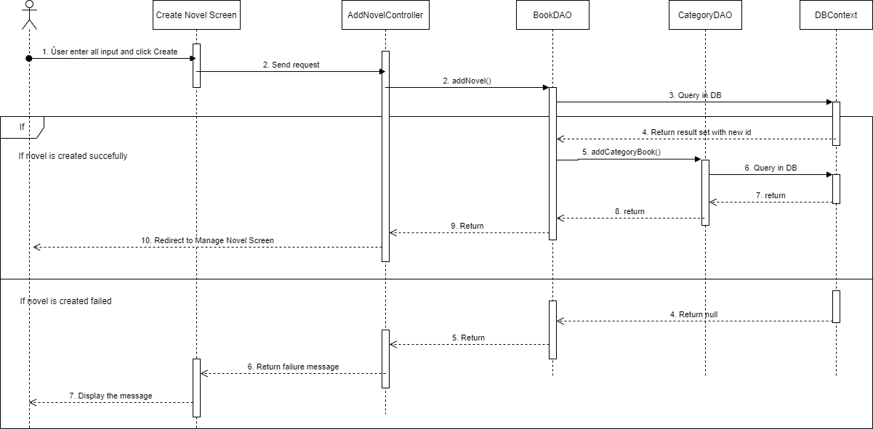

### d. Data queries

1. addNovel:

INSERT INTO [dbo].[Book]

([title]

,[authorId]

,[price]

,[is_sale]

,[image]

,[description])

OUTPUT Inserted.[id]"

VALUES ( ? "

, (SELECT [id] FROM [Author] WHERE [userId] = ?) "

, ? "

, ? "

, ? "

, ? )

2. addCategoryBook

INSERT INTO [CategoryBook] ([bookId], [CategoryId])

VALUES ( ?, ?)

## 33.2 Update Novel

### a. Class Diagram

### b. Class Specifications

#### UpdateBookController

***Class Methods***

|  |  |  |
| --- | --- | --- |
| **No** | **Method** | **Description** |
| *1* | *doGet()* | *Handles the HTTP <code>GET</code> method.* |
| *2* | *doPost()* | *Handles the HTTP <code>POST</code> method.* |

#### BookDAO

***Class Methods***

|  |  |  |
| --- | --- | --- |
| **No** | **Method** | **Description** |
| *1* | *getBookById* | *Method used to get the data of book that has the input id and return the book* |
| *2* | *editNovel* | *Method used to update Novel into database and return an integer represents sql query result* |

#### CategoryDAO

***Class Methods***

|  |  |  |
| --- | --- | --- |
| **No** | **Method** | **Description** |
| *1* | *getAllCategory* | *Method used to get all category and its information in database. Return an array list <Category> represents the data of books.* |
| *2* | *editCategoryBook* | *Method used to insert new data of related genres of a novel into CategoryBook table. Return an integer represents execution function result.* |

#### DBContext

***Class Methods***

|  |  |  |
| --- | --- | --- |
| **No** | **Method** | **Description** |
| *1* | *getConnection* | *Method used to connect to the database. Return a <Code>java.sql.Connection</Code> represents a connection to the database.* |

### c. Sequence Diagram(s)

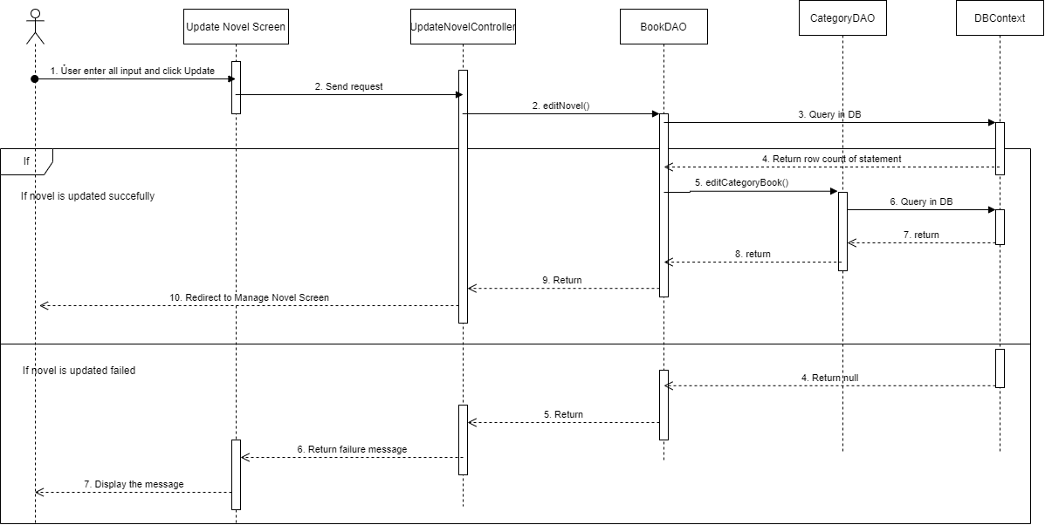

### d. Data queries

1. *editNovel*

UPDATE [Book] "

SET [title]= ?"

, [price] = ?"

, [is_sale] = ?"

, [image] = ?"

, [description] = ?"

WHERE [id] = ? "

2. getBookById

SELECT [Book].[id]

,[title]

,[authorId]

,[userId]"

,[Author].[name]

,[rating]

,[favourite]

,[price]

,[is_sale]

,[image]

,[description]

,[views]

,[status]

FROM [Book]"

INNER JOIN [Author] ON [Book].[authorId] = [Author].[id]"

WHERE [Book].[id] = ?

3. edit Category

INSERT INTO [CategoryBook] ([bookId], [CategoryId])"

VALUES ( ? ,? )

## 33.3 Delete/Disable/Enable Novel

### a. Class Diagram

### b. Class Specifications

#### ChangeStatusController

***Class Methods***

|  |  |  |
| --- | --- | --- |
| **No** | **Method** | **Description** |
| *1* | *doGet()* | *Handles the HTTP <code>GET</code> method.* |
| *2* | *doPost()* | *Handles the HTTP <code>POST</code> method.* |

#### BookDAO

***Class Methods***

|  |  |  |
| --- | --- | --- |
| **No** | **Method** | **Description** |
| *1* | *changeStatusById* | *Method used to update status column of the book tuple in database that has the input id.* |
| *2* | *deleteBook* | *Method used to delete entire record of a novel in database. Input is novel id.* |

#### CategoryDAO

***Class Methods***

|  |  |  |
| --- | --- | --- |
| **No** | **Method** | **Description** |
| *1* | *getAllCategory* | *Method used to get all category and its information in database. Return an array list <Category> represents the data of books.* |

#### DBContext

***Class Methods***

|  |  |  |
| --- | --- | --- |
| **No** | **Method** | **Description** |
| *1* | *getConnection* | *Method used to connect to the database. Return a <Code>java.sql.Connection</Code> represents a connection to the database.* |

### c. Sequence Diagram(s)

### d. Data queries

1. changeStatus

UPDATE [Book]"

SET [status] = 1 ^ [status] "

WHERE [id] = ?"

2. deleteBook

DELETE FROM [Book]

WHERE [id] = ?

## 34 View List Author

### a. Class Diagram

### b. Class Specifications

#### AuthorController

***Class Methods***

|  |  |  |
| --- | --- | --- |
| **No** | **Method** | **Description** |
| *1* | *doGet()* | *Handles the HTTP <code>GET</code> method.* |

#### DBContext

***Class Methods***

|  |  |  |
| --- | --- | --- |
| **No** | **Method** | **Description** |
| *1* | *getConnection* | *Method used to connect to the database. Return a <Code>java.sql.Connection</Code> represents a connection to the database.* |

#### AuthorDAO

***Class Methods***

|  |  |  |
| --- | --- | --- |
| **No** | **Method** | **Description** |
| *1* | *getAllAuthor ()* | *Method used to return the list of authors which are generated.Return a List of <Code>model.Author</Code> represents the author’s data* |
| *2* | *getAllUser()* | *Method used to return the list of authors which are user sign up .Return a List of <Code>model.Author</Code> represents the author’s data* |
| *3* | *getByPage()* | *Method used to resize the list of user accounts .Inputs are list of author , start-point and end-point .Return a List of <Code>model.Author</Code> represents the user’s data* |

### c. Sequence Diagram(s)

### d. Database queries

getAllAuthor() : SELECT * FROM [dbo].[Author]

WHERE [userId] IS NULL

*getAllUser* () : SELECT * FROM [dbo].[Author]

WHERE [userId] IS NOT NULL

## 35 Edit Author

### a. Class Diagram

### b. Class Specifications

#### AuthorController

***Class Methods***

|  |  |  |  |
| --- | --- | --- | --- |
| **No** | **Method** |  | **Description** |
| *1* | *doGet()* |  | *Handles the HTTP <code>GET</code> method.* |
| *2* | *doPost()* |  | *Handles the HTTP <code>POST</code> method.* |

#### LoadAuthor

***Class Methods***

|  |  |  |
| --- | --- | --- |
| **No** | **Method** | **Description** |
| *1* | *doGet()* | *Handles the HTTP <code>GET</code> method.* |

#### DBContext

***Class Methods***

|  |  |  |
| --- | --- | --- |
| **No** | **Method** | **Description** |
| *1* | *getConnection* | *Method used to connect to the database. Return a <Code>java.sql.Connection</Code> represents a connection to the database.* |

#### AuthorDAO

***Class Methods***

|  |  |  |
| --- | --- | --- |
| **No** | **Method** | **Description** |
| *1* | *getAllAuthor ()* | *Method used to return the list of authors which are generated.Return a List of <Code>model.Author</Code> represents the author’s data* |
| *2* | *getAllUser()* | *Method used to return the list of authors which are user sign up .Return a List of <Code>model.Author</Code> represents the author’s data* |
| *3* | *getByPage()* | *Method used to resize the list of user accounts .Inputs are list of author , start-point and end-point .Return a List of <Code>model.User</Code> represents the user’s data* |
| *4* | *updateAu()* | *Method used to update the new name for a author generated . Input is author name .* |
| *5* | *searchByAname()* | *Method used to return the list of authors which are generated with the name need search .Input is a string name . Return a List of <Code>model.Author</Code> represents the author’s data* |
| *6* | *searchByUname ()* | *Method used to resize the list of user accounts with the name need search .Inputs is a string name .Return a List of <Code>model.User</Code> represents the user’s data* |

#### BookDAO

***Class Methods***

|  |  |  |
| --- | --- | --- |
| **No** | **Method** | **Description** |
| *1* | *getAllBooksByAuthorId ()* | *Method used to return the list of books belong to an author. Input is the id of author . Return a List of <Code>model.Book</Code> represents the author’s data* |
| *2* | *getByPage ()* | *Method used to resize the list of user accounts .Inputs are list of book , start-point and end-point .Return a List of <Code>model.Book</Code> represents the user’s data* |

### c. Sequence Diagram(s)

### d. Database queries

getAllAuthor() : SELECT * FROM [dbo].[Author]

WHERE [userId] IS NULL

*getAllUser* () : SELECT * FROM [dbo].[Author]

WHERE [userId] IS NOT NULL

*updateAu* () : UPDATE [dbo].[Author] SET [name] = ?

WHERE [Author].[id] = ?

*searchByAname* SELECT * FROM [dbo].[Author]

WHERE WHERE [name] LIKE ? AND [userId] IS NULL

*searchByUname* (): SELECT * FROM [dbo].[Author]

WHERE WHERE [name] LIKE ? AND [userId] IS NOT NULL

*getAllBooksByAuthorId():* SELECT * FROM [Book]

INNER JOIN [Author] ON [Book].[authorId] = [Author].[id]

WHERE [authorId] = ? AND [status] != 0

## 36 Admin Panel

### a. Class Diagram

### b. Class Specifications

#### DashBoard

***Class Methods***

|  |  |  |
| --- | --- | --- |
| **No** | **Method** | **Description** |
| *1* | *doGet()* | *Handles the HTTP <code>GET</code> method.* |

#### DBContext

***Class Methods***

|  |  |  |
| --- | --- | --- |
| **No** | **Method** | **Description** |
| *1* | *getConnection* | *Method used to connect to the database. Return a <Code>java.sql.Connection</Code> represents a connection to the database.* |

#### AuthorDAO

***Class Methods***

|  |  |  |
| --- | --- | --- |
| **No** | **Method** | **Description** |
| *1* | *getAllAuthor ()* | *Method used to return the list of authors which are generated.Return a List of <Code>model.Author</Code> represents the author’s data* |
| *2* | *getAllUser()* | *Method used to return the list of authors which are user sign up .Return a List of <Code>model.Author</Code> represents the author’s data* |
| *3* | *getNumQuater ()* | *Method used to get the number of sign up account in each quarter from 2 year nearly. Input are year now and formal. Return a List of <Code>Integer</Code> represents the data* |
| *4* | *getNumYear ()* | *Method used to get the number of sign up account in 1month current year. Input are month and current year. Return <Code>Integer</Code> represents the data* |

#### UserDAO

***Class Methods***

|  |  |  |
| --- | --- | --- |
| **No** | **Method** | **Description** |
| *1* | *getAllUsers ()* | *Method used to return the list all user .Return a List of <Code>model.User</Code> represents the user’s data* |

#### BookDAO

***Class Methods***

|  |  |  |
| --- | --- | --- |
| **No** | **Method** | **Description** |
| *1* | *count ()* | *Method used to return the number of book . Return <Code>Integer</Code> represents the data* |

#### ReportDAO

***Class Methods***

|  |  |  |
| --- | --- | --- |
| **No** | **Method** | **Description** |
| *1* | *count ()* | *Method used to return the report of book. . Return <Code>Integer</Code> represents the data* |

#### CommentDAO

***Class Methods***

|  |  |  |
| --- | --- | --- |
| **No** | **Method** | **Description** |
| *1* | *count ()* | *Method used to return the comment of book. Return <Code>Integer</Code> represents the data* |

### c. Sequence Diagram(s)

### d. Database queries

getAllAuthor() : SELECT * FROM [dbo].[Author]

WHERE [userId] IS NULL

*getAllUser* () : SELECT * FROM [dbo].[Author]

WHERE [userId] IS NOT NULL

*getNumQuater* () :

SELECT COUNT([Author].[date])

FROM[dbo].[Author]

WHERE[date] <= '" + ? + "-1-1')

UNION ALL

(SELECT COUNT([Author].[date])

FROM[dbo].[Author]

WHERE[date] BETWEEN '" + ? + "-1-1' AND '" + ? + "-3-31')

UNION ALL

(SELECT COUNT([Author].[date])

FROM[dbo].[Author]

WHERE[date] BETWEEN '" + ? + "-4-1' AND '" + ? + "-6-30')

UNION ALL

(SELECT COUNT([Author].[date])

FROM[dbo].[Author]

WHERE[date] BETWEEN '" + ? + "-7-1' AND '" + ? + "-9-30')

UNION ALL

(SELECT COUNT([Author].[date])

FROM[dbo].[Author]

WHERE[date] BETWEEN '" + ? + "-10-1' AND '" + ? + "-12-31')

UNION ALL

(SELECT COUNT([Author].[date])

FROM[dbo].[Author]

WHERE[date] BETWEEN '" + ? + "-1-1' AND '" + ? + "-3-31')

UNION ALL

(SELECT COUNT([Author].[date])

FROM[dbo].[Author]

WHERE[date] BETWEEN '" + ? + "-4-1' AND '" + ? + "-6-30')

UNION ALL

(SELECT COUNT([Author].[date])

FROM[dbo].[Author]

WHERE[date] BETWEEN '" + ? + "-7-1' AND '" + ? + "-9-30')

UNION ALL

(SELECT COUNT([Author].[date])

FROM[dbo].[Author]

WHERE[date] BETWEEN '" + ? + "-10-1' AND '" + ? + "-12-31')

*getNumYear :* (SELECT COUNT([Author].[id])

FROM [dbo].[Author]

WHERE YEAR([date]) = ? AND MONTH([date]) = ?)

*getAllUsers* (): Select * from [User] where [is_super] < 5

*count():* SELECT COUNT([id])

FROM [dbo].[Book]

*count():* SELECT COUNT([id])

FROM [dbo].[Comment]

*count():* SELECT COUNT([id])

FROM [dbo].[ReportDetail]

## 37 Admin Panel

### a. Class Diagram

### b. Class Specifications

#### DashBoard

***Class Methods***

|  |  |  |
| --- | --- | --- |
| **No** | **Method** | **Description** |
| *1* | *doGet()* | *Handles the HTTP <code>GET</code> method.* |

#### DBContext

***Class Methods***

|  |  |  |
| --- | --- | --- |
| **No** | **Method** | **Description** |
| *1* | *getConnection* | *Method used to connect to the database. Return a <Code>java.sql.Connection</Code> represents a connection to the database.* |

#### AuthorDAO

***Class Methods***

|  |  |  |
| --- | --- | --- |
| **No** | **Method** | **Description** |
| *1* | *getAllAuthor ()* | *Method used to return the list of authors which are generated.Return a List of <Code>model.Author</Code> represents the author’s data* |
| *2* | *getAllUser()* | *Method used to return the list of authors which are user sign up .Return a List of <Code>model.Author</Code> represents the author’s data* |
| *3* | *getNumQuater ()* | *Method used to get the number of sign up account in each quarter from 2 year nearly. Input are year now and formal. Return a List of <Code>Integer</Code> represents the data* |
| *4* | *getNumYear ()* | *Method used to get the number of sign up account in 1month current year. Input are month and current year. Return <Code>Integer</Code> represents the data* |

#### UserDAO

***Class Methods***

|  |  |  |
| --- | --- | --- |
| **No** | **Method** | **Description** |
| *1* | *getAllUsers ()* | *Method used to return the list all user .Return a List of <Code>model.User</Code> represents the user’s data* |

#### BookDAO

***Class Methods***

|  |  |  |
| --- | --- | --- |
| **No** | **Method** | **Description** |
| *1* | *count ()* | *Method used to return the number of book . Return <Code>Integer</Code> represents the data* |

#### ReportDAO

***Class Methods***

|  |  |  |
| --- | --- | --- |
| **No** | **Method** | **Description** |
| *1* | *count ()* | *Method used to return the report of book. . Return <Code>Integer</Code> represents the data* |

#### CommentDAO

***Class Methods***

|  |  |  |
| --- | --- | --- |
| **No** | **Method** | **Description** |
| *1* | *count ()* | *Method used to return the comment of book. Return <Code>Integer</Code> represents the data* |

### d. Database queries

getAllAuthor() : SELECT * FROM [dbo].[Author]

WHERE [userId] IS NULL

*getAllUser* () : SELECT * FROM [dbo].[Author]

WHERE [userId] IS NOT NULL

*getNumQuater* () :

SELECT COUNT([Author].[date])

FROM[dbo].[Author]

WHERE[date] <= '" + ? + "-1-1')

UNION ALL

(SELECT COUNT([Author].[date])

FROM[dbo].[Author]

WHERE[date] BETWEEN '" + ? + "-1-1' AND '" + ? + "-3-31')

UNION ALL

(SELECT COUNT([Author].[date])

FROM[dbo].[Author]

WHERE[date] BETWEEN '" + ? + "-4-1' AND '" + ? + "-6-30')

UNION ALL

(SELECT COUNT([Author].[date])

FROM[dbo].[Author]

WHERE[date] BETWEEN '" + ? + "-7-1' AND '" + ? + "-9-30')

UNION ALL

(SELECT COUNT([Author].[date])

FROM[dbo].[Author]

WHERE[date] BETWEEN '" + ? + "-10-1' AND '" + ? + "-12-31')

UNION ALL

(SELECT COUNT([Author].[date])

FROM[dbo].[Author]

WHERE[date] BETWEEN '" + ? + "-1-1' AND '" + ? + "-3-31')

UNION ALL

(SELECT COUNT([Author].[date])

FROM[dbo].[Author]

WHERE[date] BETWEEN '" + ? + "-4-1' AND '" + ? + "-6-30')

UNION ALL

(SELECT COUNT([Author].[date])

FROM[dbo].[Author]

WHERE[date] BETWEEN '" + ? + "-7-1' AND '" + ? + "-9-30')

UNION ALL

(SELECT COUNT([Author].[date])

FROM[dbo].[Author]

WHERE[date] BETWEEN '" + ? + "-10-1' AND '" + ? + "-12-31')

*getNumYear :* (SELECT COUNT([Author].[id])

FROM [dbo].[Author]

WHERE YEAR([date]) = ? AND MONTH([date]) = ?)

*getAllUsers* (): Select * from [User] where [is_super] < 5

*count():* SELECT COUNT([id])

FROM [dbo].[Book]

*count():* SELECT COUNT([id])

FROM [dbo].[Comment]

*count():* SELECT COUNT([id])

FROM [dbo].[ReportDetail]

## 38 List book of this author

### a. Class Diagram

### b. Class Specifications

- BookDAO class

|  |  |  |
| --- | --- | --- |
| **No** | **Method** | **Description** |
| 01 | getAllBooksByAuthorId(aid: int) | Get a list of books from database by authorId |

- AuthorDAO class

|  |  |  |
| --- | --- | --- |
| **No** | **Method** | **Description** |
| 01 | getAuthorById(aid: int) | Get author’s information by their ID |

- DBContext class

|  |  |  |
| --- | --- | --- |
| No | Method | Description |
| 01 | getConnection() | Connecting with database |

-BookAuthor class

|  |  |  |
| --- | --- | --- |
| **No** | **Method** | **Description** |
| 01 | doGet | Handles the HTTP <code>GET</code> method. |

### c. Sequence Diagrams(s)

### d. Database queries

- getAuthorById(aid: int): SELECT * from Author where aid = ?

- getAllBooksByAuthorId(aid: int): "SELECT [Book].[id]\n"

+ " ,[title]\n"

+ " ,[authorId]\n"

+ " ,[Author].[name]\n"

+ " ,[rating]\n"

+ " ,[favourite]\n"

+ " ,[price]\n"

+ " ,[is_sale]\n"

+ " ,[image]\n"

+ " ,[description]\n"

+ " ,[views]\n"

+ " ,[status]\n"

+ " FROM [Book]"

+ " INNER JOIN [Author] ON [Book].[authorId] = [Author].[id]"

+ " WHERE [authorId] = ?\n"

+ " AND [status] != 0 "

## 39 Add chapter for user’s novel

### a. Class Diagram

### b. Class Specifications

- VolumeDAO class

|  |  |  |
| --- | --- | --- |
| **No** | **Method** | **Description** |
| 01 | getVolumeByBookId(bookId: int) | Get volume list of a book by its ID |
| 02 | getVolumeById(volId: int) | Get volume’s information by its ID |

- ChapterDAO class

|  |  |  |
| --- | --- | --- |
| **No** | **Method** | **Description** |
| 01 | getChapterById(chapterID: int) | Get chapter’s information by its ID |
| 02 | getChapterByBookId(bookId: int) | Get chapter list of a book by its ID |
| 03 | addChapter(chapter: Chapter) | Add chapter to the database within information |

- BookDAO class

|  |  |  |
| --- | --- | --- |
| **No** | **Method** | **Description** |
| 01 | getBookById(bookid: int) | Get book’s information by its ID |

- DBContext class

|  |  |  |
| --- | --- | --- |
| No | Method | Description |
| 01 | getConnection() | Connecting with database |

- AddChapterController class

|  |  |  |
| --- | --- | --- |
| **No** | **Method** | **Description** |
| 01 | doGet | Handles the HTTP <code>GET</code> method. |
| 02 | doPost | Handles the HTTP <code>POST</code> method. |

### c. Sequence Diagram

### d. Data queries

- addChapter(): INSERT INTO [dbo].[Chapter]\n"

+ " ([volumeId]"

+ " ,[no]\n"

+ " ,[title]\n"

+ " ,[status]\n"

+ " ,[content])\n"

+ " OUTPUT [Inserted].[id]"

+ " VALUES\n"

+ " ( ? "

+ " , (SELECT COUNT([no]) FROM [dbo].[Chapter] WHERE [volumeId] = ?)+1 "

+ " , ? "

+ " , ? "

+ " , ? )

## 40 Edit chapter for user’s novel

### a. Class Diagram

### b. Class specification

- ChapterDAO

|  |  |  |
| --- | --- | --- |
| **No** | **Method** | **Description** |
| 01 | getChapterById(chapterID: int) | Get chapter’s information by its ID |
| 02 | getChapterByBookId(bookId: int) | Get chapter list of a book by its ID |
| 03 | editChapter(chapter: Chapter) | Change chapter’s information |

- DBContext class

|  |  |  |
| --- | --- | --- |
| No | Method | Description |
| 01 | getConnection() | Connecting with database |

- EditChapterController class

|  |  |  |
| --- | --- | --- |
| **No** | **Method** | **Description** |
| 01 | doGet | Handles the HTTP <code>GET</code> method. |
| 02 | doPost | Handles the HTTP <code>POST</code> method. |

### c. Sequence diagram

### d. Database queries

- editChapter(): "UPDATE [dbo].[Chapter]\n"

+ " SET [title] = ? "

+ " ,[status] = ?"

+ " ,[content] = ? "

+ " WHERE [id] = ? "

## 41 Delete chapter for user’s novel

### a. Class Diagram

### b. Class Specification

- ChapterDAO

|  |  |  |
| --- | --- | --- |
| **No** | **Method** | **Description** |
| 01 | getChapterById(chapterID: int) | Get chapter’s information by its ID |
| 02 | getChapterByBookId(bookId: int) | Get chapter list of a book by its ID |
| 03 | deleteChapter(chapter: Chapter) | Delete chapter’s all information |

- DBContext class

|  |  |  |
| --- | --- | --- |
| No | Method | Description |
| 01 | getConnection() | Connecting with database |

- DeleteChapterController class

|  |  |  |
| --- | --- | --- |
| **No** | **Method** | **Description** |
| 01 | doGet | Handles the HTTP <code>GET</code> method. |
| 02 | doPost | Handles the HTTP <code>POST</code> method. |

### c. Sequence diagram

### d. Database queries

- deleteChapter(ChapterId): "DELETE FROM [dbo].[Chapter] WHERE [id] = ? "

## 42.1 View Category

#### a. Class Diagram

#### b. Class Specifications

##### Controller.admin.category.ViewCategoryController

|  |  |  |
| --- | --- | --- |
| **No** | **Method** | **Description** |
| 01 | doGet | Handles the HTTP <code>GET</code> method. |
| 02 | doPost | Handles the HTTP <code>POST</code> method. |

##### Model.product.Category

|  |  |  |
| --- | --- | --- |
| **No** | **Method** | **Description** |
| 01 | getName() : String | Get name of category |
| 02 | getId : int | Get ID of category |
| 03 | setId(int id) : void | Set number as ID of category |
| 04 | setName(String name) : String | Set string as name of category |

##### context.product.CategoryDAO

|  |  |  |
| --- | --- | --- |
| **No** | **Method** | **Description** |
| 01 | countBook(Category category) : int | Count number of books in input category |
| 02 | getAllCategory_SortById() : ArrayList<Category> | Get all categories from database order by id ascending |

#### c. Sequence Diagram(s)

#### d. Database queries

##### getAllCategory_SortById()

SELECT [id] , [name] FROM [Category] ORDER BY [id] ASC

##### countBook(Category category)

select COUNT (*) as total from Category c

INNER JOIN CategoryBook cb ON c.id = cb.categoryId

where c.id = ?

## 42.2 Add Category

#### a. Class Diagram

#### b. Class Specifications

##### Controller.admin.category.AddCategoryController

|  |  |  |
| --- | --- | --- |
| **No** | **Method** | **Description** |
| 01 | doGet | Handles the HTTP <code>GET</code> method. |
| 02 | doPost | Handles the HTTP <code>POST</code> method. |

##### context.product.CategoryDAO

|  |  |  |
| --- | --- | --- |
| **No** | **Method** | **Description** |
| 01 | addCategory(String name): int | Add new category into database |

#### c. Sequence Diagram(s)

#### d. Database queries

##### addCategory(String name)

insert [Category] ([name]) values (?)

## 42.3 Update Category

#### a. Class Diagram

#### b. Class Specifications

##### Controller. admin.category.UpdateCategoryController

|  |  |  |
| --- | --- | --- |
| **No** | **Method** | **Description** |
| 01 | doGet | Handles the HTTP <code>GET</code> method. |
| 02 | doPost | Handles the HTTP <code>POST</code> method. |

##### context.product.CategoryDAO

|  |  |  |
| --- | --- | --- |
| **No** | **Method** | **Description** |
| 01 | editCategory(int id, String editName) : int | Rename category have input id |

#### c. Sequence Diagram(s)

#### d. Database queries

##### editCategory(int id, String editName)

update [Category] set [name]= ? where [id]=?

## 42.4 Remove Category

#### a. Class Diagram

#### b. Class Specifications

##### Controller. admin.category.RemoveCategoryController

|  |  |  |
| --- | --- | --- |
| **No** | **Method** | **Description** |
| 01 | doGet | Handles the HTTP <code>GET</code> method. |
| 02 | doPost | Handles the HTTP <code>POST</code> method. |

##### context.product.CategoryDAO

|  |  |  |
| --- | --- | --- |
| **No** | **Method** | **Description** |
| 01 | delBookCategory(int id) : void | Remove category have input id from all books which have this category |
| 02 | : void | Remove category have input id from database |

#### c. Sequence Diagram(s)

#### d. Database queries

##### delBookCategory(int id)

DELETE FROM [CategoryBook] WHERE [categoryId] = ?

##### delCategory(int id)

delete from [Category] where [id] = ?

## 43 Bookshelf

#### a. Class Diagram

#### b. Class Specifications

##### Controller.payment.ViewWalletController

|  |  |  |
| --- | --- | --- |
| **No** | **Method** | **Description** |
| 01 | doGet | Handles the HTTP <code>GET</code> method. |
| 02 | doPost | Handles the HTTP <code>POST</code> method. |

##### Context.product.BookDAO

|  |  |  |
| --- | --- | --- |
| **No** | **Method** | **Description** |
| 01 | + getNovelsPagging(User user, int pageSize, int pageIndex) : ArrayList<Book> | Get pageSize novels in pageIndex from database |
| 02 | countNovel(User user) : int | Count number of novels that input user wrote |

##### Context.product.BookOwnDAO

|  |  |  |  |
| --- | --- | --- | --- |
| **No** | **Method** | **Description** | |
| 01 | + getOwnBooksPagging(User user, int pageSize, int pageIndex) : ArrayList<Book> | | Get pageSize books that user bought in pageIndex from database |
| 02 | Count(User user) : int | | Count number of books that user bought |

##### Context.product.FavoriteDAO

|  |  |  |  |
| --- | --- | --- | --- |
| **No** | **Method** | **Description** | |
| 01 | + getFavorBooksPagging(User user, int pageSize, int pageIndex) : ArrayList<Book> | | Get pageSize books that user added to favorite in pageIndex from database |
| 02 | count(User user) : int | | Count number of books that user added to favorite |

#### c. Sequence Diagram(s)

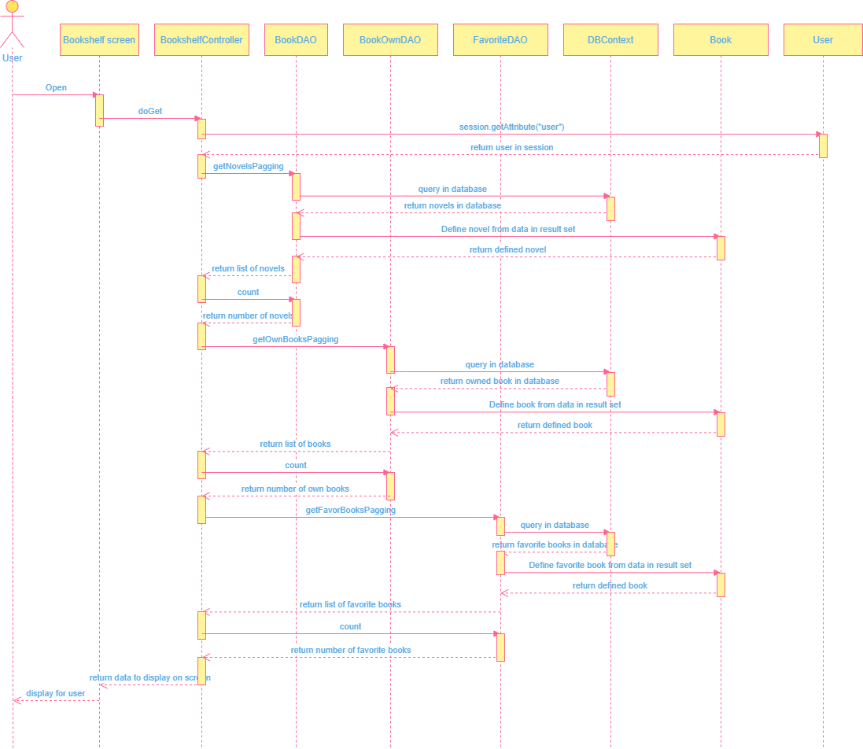

#### d. Database queries

##### getFavorBooksPagging(User user, int pageSize, int pageIndex)

select b.id, b.[title], b.[authorId], b.[rating], b.[favourite]

,b.[price], b.[is_sale], b.[image], b.[description], b.[views], b.[status]

from [Favourite] f inner join Book b on f.bid = b.id

where f.uid = ?

ORDER BY b.id ASC OFFSET ? * (?-1) ROWS FETCH NEXT ? ROWS ONLY

##### FavoriteDAO.count(User user) : int

SELECT COUNT(*) as total FROM [Favourite] WHERE uid = ?

##### getOwnBooksPagging(User user, int pageSize, int pageIndex)

select bo.bookId, b.[title], b.[authorId], b.[rating], b.[favourite], b.[price]

,b.[is_sale], b.[image], b.[description], b.[views], b.[status]

from [Book_Own] bo inner join Book b on bo.bookId = b.id

where bo.userId = ?

ORDER BY b.id ASC OFFSET ? * (?-1) ROWS FETCH NEXT ? ROWS ONLY

##### getNovelsPagging(User user, int pageSize, int pageIndex)

SELECT [Book].[id], [title], [authorId],[Author].[name] ,[rating] ,[favourite]

,[price],[is_sale],[image],[description] ,[views] status]

FROM [Book] INNER JOIN [Author] ON [Book].[authorId] = [Author].[id]

WHERE [Author].[userId] = ? ORDER BY [Book].id ASC

OFFSET ? * (?-1) ROWS FETCH NEXT ? ROWS ONLY

##### BookOwnDAO.count(User user)

SELECT COUNT(*) as total FROM [Book_Own] WHERE userId = ?

##### countNovel(User user)

SELECT COUNT(*) as total FROM [Book] INNER JOIN [Author] on [Book].authorId = [Author].id

WHERE [Author].userId =

# III. Database Design

## 1. Database Schema

## 2. Table Description

|  |  |  |
| --- | --- | --- |
| **No** | **Table** | **Description** |
| 01 | Book | - Primary key: ID  - Foreign key :<none>  - Attribute: tittle, author, categoryID, rating, favourite, price, is_sale, image, description, views |
| 02 | User | - Primary key: ID  - Foreign key: <none>  - Attribute: fullname, gender, dob, email, phone, address,username, password, is_super |
| 03 | Favourite | - Primary key: uID  - Foreign key: uID(User: ID), bID(Book: ID)  - Attribute: <none> |
| 04 | Category | - Primary key: ID  - Foreign key: ID(Book: categoryID)  - Attribute: name |
| 05 | Star | - Primary key: bID  - Foreign key: bID(Book: ID)  - Attribute: <none> |
| 06 | ResetToken | - Primary key: uID  - Foreign key: uID(Book: ID)  - Attribute: token, expired data |
| 07 | Volume | - Primary key: bID, vol  - Foreign key: bID(Book: ID)  - Attribute: vol_name |
| 08 | Chapter | - Primary key: bID, vol, chapter  - Foreign key: bID(Book: ID), vol(Volumn: vol)  - Attribute: chapter_name, content |
| 09 | Transaction | - Primary key: userId  - Foreign key: userId(User: ID)  - Attribute: balanceBefore, amount, balanceAfter, transactionTime, type, status |
| 10 | Comment | - Primary key: bookId, userID  - Foreign key: bookId(Book: ID), userId(User: ID)  - Attribute: comment |
| 11 | Content | - Primary key: chapterId  - Foreign key: chapterId(Chapter: ID)  - Attribute: paragraph, content |
| 12 | Report | - Primary key: id  - Foreign key: <none>  - Attribute: title |
| 13 | ReportDetail | - Primary key: id  - Foreign key: reportId(Report: ID), bookId(Book: ID), userId(User: ID)  - Attribute:note |